Land use gradients drive spatial variation in Lassa fever host communities in Eastern Sierra Leone.

2023-06-12

# Author details.

David Simons 1,2,3, Rory Gibb 2, Umaru Bangura 4,5, Dianah Sondufu 5, Joyce Lamin 5, James Koninga 6, Momoh Jimmy 6, Mike Dawson 5, Joseph Lahai 5, Rashid Ansumana 5, Deborah Watson-Jones 3,7, Richard Kock 1, Kate E. Jones 2.

1 Centre for Emerging, Endemic and Exotic Diseases, The Royal Veterinary College, London, United Kingdom

2 Centre for Biodiversity and Environment Research, Department of Genetics, Evolution and Environment, University College London, London, United Kingdom

3 Clinical Research Department, London School of Hygiene and Tropical Medicine, London, United Kingdom

4 Bernard-Nocht Institute for Tropical Medicine

5 Njala University, Bo, Sierra Leone

6 Kenema Government Hospital, Kenema, Sierra Leone

7 Mwanza Intervention Trials Unit, National Institute for Medical Research, Mwanza, Tanzania

# Abstract

The natal multimammate mouse (*Mastomys natalensis*) is the primary reservoir species of the zoonotic infectious disease, Lassa fever (*Lassa mammarenavirus*). The spatial occurrence and abundance of this rodent species is regulated by the human environment and biotic interactions within small mammal communities. However, little is known about these effects even in highly endemic areas of Lassa fever. Here, we conducted a rodent trapping study in a Lassa endemic region within the Eastern Province, Sierra Leone to understand how *M. natalensis* is distributed across a gradient of landuse types and how its distribution may be influenced by the small mammal community structure. Using data from 43,226 trap nights from four village sites between 2020-2023, we developed a Bayesian multiple species occupancy model, accounting for imperfect detection, to show that, locally within study sites, *M. natalensis* occupancy increased along a gradient from less to more human dominated habitats (i.e., from forest through agriculture to village), but that this effect did not hold at broader spatial scales, with lower occupancy in peri-urban than rural study sites. Interactions with invasive rodent species within the small mammal community appeared to regulate the occupancy of *M. natalensis*, with the presence of *Mus musculus*, but not *Rattus rattus* associated with a reduced probability of occupancy of *M. natalensis*. This finding may help to explain prior observations of lower-than-expected human cases of Lassa fever from urban settings in endemic regions. Our findings highlight that land use drives spatial heterogeneity in rodent reservoir populations, through impacting both habitat and small mammal community dynamics, with implications for the hazard of Lassa fever outbreaks. Therefore, to quantify public health risk and effectively allocate limited healthcare resources more accurate characterisation of rodent communities is required in regions at risk of Lassa fever outbreaks.

# Introduction

Global mammalian biodiversity is declining, with varied direct effects of biodiversity change on the risk of zoonotic infectious disease spillover into human populations (Sala et al. 2000; Mantyka-Pringle et al. 2015; IPBES 2020). Land use change is identified as a key driver in the decline of multiple measures of mammalian species biodiversity including; taxonomic diversity (the number and relative abundance of taxa), functional biodiversity (an increase in the abundance of generalist, synanthropic animals) and interaction diversity (the biotic interactions among species) (Naeem, Duffy, and Zavaleta 2012; Glidden et al. 2021). Specifically, within rodent associated zoonoses systems, conversion of natural habitats to agricultural or urban ecosystems preferentially favours, generalist, synanthropic species, more likely to be hosts of zoonoses increasing the potential prevalence of pathogens within human dominated environments (Gibb et al. 2020; Young et al. 2014).

The role of mammalian community structure in zoonosis spillover risk is complex. The “Dilution effect” posits that increased species taxonomic diversity reduces pathogen prevalence within a system, therefore reducing spillover risk (Keesing, Holt, and Ostfeld 2006). In contrast, the “Amplification effect” proposes that infectious disease transmission may be increased in species rich systems (Randolph and Dobson 2012). A greater mechanistic understanding of the association of biodiversity, beyond species richness, incorporating community structure, biotic interactions between species and differential responses to anthropogenic land use change is required (Salkeld, Padgett, and Jones 2013; Glidden et al. 2021). These approaches have only been taken for a few rodent associated zoonoses.

Rodents are identified as an important mammalian host taxa for zoonotic diseases (Han et al. 2015; Mendoza et al. 2019). Rodent associated zoonoses where the mechanistic contribution of community structure, biotic interactions between species and the effect of land use change includes Lyme disease (caused by *Borrelia burgdorferi sensu lato*). Here, reduction in predation pressure - driven by land use change - on rodent species’ has led to increased abundance of the primary rodent reservoir species, subsequently increasing pathogen abundance and spillover risk (Ostfeld and Holt 2004). The effect of land use change on rodent communities has also been investigated in an East African setting, where conversion to agricultural land was associated with a reduction in small mammal diversity, but no general trend in the prevalence of multiple zoonotic pathogens (Young et al. 2017). These examples, along with others, suggest an idiosyncratic response to zoonotic disease risk in response to land use change (Mendoza et al. 2019). The effect of land use change on rodent communities in the Lassa fever disease system in West Africa has only been explored in a limited area of the endemic region, with most studies solely focussing on the role of the primary rodent reservoir (Fichet-Calvet et al. 2014, 2005; Fichet-Calvet et al. 2009; Olayemi et al. 2018; Arruda et al. 2021).

Lassa fever, caused by *Lassa mammarenavirus* (LASV) is an endemic zoonotic infectious disease in eight West African countries (Nigeria, Guinea, Sierra Leone, Liberia, Mali, Benin, Ghana and Togo) (World Health Organisation 2022). There burden of this zoonosis on human communities is unclear with large uncertainties around estimates of the annual number human of infections between 100,000-4,383,600 (McCormick et al. 1987; Basinski et al. 2021). Most infections remain undetected and it is estimated that up-to 80% of these infections are pauci- or asymptomatic (McCormick et al. 1987). Few infections are expected to lead to clinically severe cases but outcomes in confirmed clinical cases remain poor, with a reported case fatality rate of 16.5% (Simons 2022). Within the endemic region locations of disease outbreaks are spatially heterogeneous, the cause of this is not well understood (Grant et al. 2023; Agbonlahor et al. 2021; Gibb et al. 2017).

A potential driver of the observed spatial heterogeneity in Lassa fever outbreaks may be the distribution of the the primary reservoir host, *Mastomys natalensis*. This commensal, synanthropic rodent species is found in 13 of 14 continental West African nations (the species has not been reported from The Gambia) and in all other sub-Saharan African countries (IUCN 2016). It is abundant in and around areas of human-dominated landscapes where it is considered a pest species (Herwig Leirs, Verhagen, and Verheyen 1993). The introduction of invasive commensal rodent species (i.e., *Rattus rattus* and *Mus musculus*) has led to increased competition for resources and displacement of *M. natalensis* from some locations within its natural range (Cuypers et al. 2017; Garba et al. 2014). Population dynamics within this reservoir species have been shown to be associated with resource availability and rainfall pulses (with increased abundance at the beginning of the dry season) (Herwig Leirs et al. 1996; Herwig Leirs et al. 1997). These environmental factors are closely associated with outbreaks of Lassa fever in human populations (Redding et al. 2021). However, this does not explain the spatial discontinuity of these outbreaks and a dearth of longitudinal, high intensity rodent trapping studies incorporating rodent community structure limits understanding of the fine scale spatial distribution of *M. natalensis* (Basinski et al. 2021; Simons et al. 2023).

*Mastomys natalensis* occurs within species rich settings in West Africa (Fichet-Calvet et al. 2009). Biotic interactions between this species and other native and invasive rodents within communities and how this structure may regulate *M. natalensis* occurrence are not well described in the Lassa fever endemic region (Hima et al. 2019; Garba et al. 2014). Outside of the endemic region the invasion of *R. rattus* and *M. musculus* have been shown to alter rodent communities leading to local exclusion of native rodent species (Lippens et al. 2017; Dalecky et al. 2015). If these processes occur within the LASV endemic region this may have important implications for pathogen prevalence, and therfore the subsequent risk of observed disease outbreaks, as competent hosts of LASV are replaced by less competent hosts. Further, land use change may facilitate establishment of these invasive species promoting restructuring of these communities (Jeffrey 1977; Benedek and Sîrbu 2018; Wells, Lakim, and O’Hara 2014).

Sierra Leone is associated with frequent outbreaks of Lassa fever in human populations (Grant et al. 2023). However, studies of rodent ecology within the country have generally focussed solely on the occurrence of *M. natalensis* (McCormick et al. 1987; Bangura et al. 2021; Bonner et al. 2007; Monath et al. 1974; Keenlyside et al. 1983). The structure of rodent communities in this region is not well understood and there is limited evidence of the spatial occurrence of invasive rodent species (Bangura et al. 2021; Bonwitt et al. 2017). Within this setting the association of anthropogenic land use change on the composition of rodent communities has not been described, limiting the ability to infer the effect of land use change on current and future disease risk. To better understand the spatial occurrence of *M. natalensis* we conducted systematic rodent sampling across a land use gradient to characterise the composition of rodent communities.

Here, we conducted repeated, systematic, rodent trapping in the Eastern province of Sierra Leone, along a land use gradient to model the association of land use and occurrence of *M. natalensis* and more generally small mammal communities. We aimed to investigate the following questions. First, what is the diversity of rodent communities in varied land use types in Eastern Sierra Leone? Second, how do patterns of land use affect the occupancy of *M. natalensis* and other sympatric rodents? Finally, is there evidence that the local spatial distribution of *M. natalensis* is regulated by biotic interactions with co-occurring species? We expect these analyses to further understanding of rodent community structures that may explain observed patterns of Lassa fever spillover within this context and the wider endemic region.

# Materials and methods

## Rodent sampling

We conducted rodent trapping surveys between October 2020-April 2023 within and around four village study sites (Baiama; latitude = 7.8375, longitude = -11.2683, Lalehun; latitude = 8.1973, longitude = -11.0803, Lambayama; latitude = 7.8505, longitude = -11.1969, and Seilama; latitude = 8.1224, longitude = -11.1936) in the Lassa fever endemic zone of the Eastern Province of Sierra Leone (Figure 1A.). Surveys were conducted within trapping grids along a landuse gradient of anthropogenic disturbance comprising, forest, agriculture (including fallow and currently in-use areas), and villages (within and outside of permanent structures) (See Supplementary Text 1 for images representative of trapping grid locations). Trapping grids were designated during the initial trapping survey session, one grid was deployed in forest land use, three to four grids were deployed in agricultural land with two grids deployed in village land use. For one village study site, Lambayama, there were no local forest areas, so this landuse type was omitted (Supplementary Figure 1 A-D). Trapping survey sessions within each village occurred four times annually with two trapping surveys in each of the rainy and dry seasons (May to November and December to April, respectively), giving a total of 10 trapping sessions over the study period (Figure 1B).

Village study sites and trapping grids within the village study sites were selected to be representative of land use in the Eastern Province of Sierra Leone and based on accessibility to the sites during all seasons and acceptability of the study protocol to the village study site communities (Supplementary Text 2). The trapping protocol was as follows: at each trapping grid 49 Sherman traps (7.62cm x 8.89cm x 22.86cm) (H.B. Sherman Traps, Tallahasee, USA), were placed in a 7 trap by 7 trap grid, traps were placed 10 metres apart in a regular grid conforming to the local landscape (median trapping grid area = 4,813m2). For traps placed within permanent structures trap placement varied from this grid structure. Permanent structures were selected semi-randomly at each visit from a grid projected over the village area, with four traps placed within each structure. The location of each individual trap within trapping grids was geolocated for subsequent data processing. Traps were baited with a locally produced mixture of oats, palm oil and dried fish. Each morning the traps were checked and closed for the day prior to re-baiting during the evening. Each trapping survey session consisted of four consecutive trap-nights (TN) at each trapping grid within the village study site (further details in Supplementary Text 2).

The location data of individual traps were harmonised to standardised trapping grid cells. First, a convex hull of a trapping grid across all trapping survey sessions was produced. Second, a regular grid was constructed to overlay this area with a grid cell size of 49 m2, individual traps were allocated to these grid cells if they were contained within its borders. This produced 2,068 unique 49 m2 trapping grid cells that individual traps were allocated to for all subsequent analysis (See Supplementary Figure 2 for a schematic of this process). The sf package in the R statistical computing language (R version 4.1.2) was used for geospatial manipulation and analysis (Pebesma 2018; R Core Team 2021). The four consecutive trap-nights obtained from each trap during a single survey are pooled as a single replicate for the subsequent statistical analysis.

All rodent handling was performed by trained researchers, rodents were sedated with halothane and euthanised prior to obtaining morphological measurements and samples of blood and tissue following published protocols (Fichet-Calvet 2014). The study protocol was approved by the Clinical Research Ethical Review Board and Animal Welfare Ethical Review Board of the Royal Veterinary College, United Kingdom (URN: 2019 1949-3), and Njala University, Sierra Leone. The rodents’ sex was determined based on external and internal genitalia. Images were obtained of rodents dorsal and ventral aspects. Age estimation was performed through description of each individual’s reproductive status (identification of perforate or imperforate vagina, scarring from prior embryo development, current pregnancy status or descent of testes and seminal vesicle development) and weighing of dried eye lenses. Carcasses were destroyed through incineration to eliminate the risk of onward pathogen transmission.

## Species classification

Species identification was performed in the field based on external characteristics using a taxonomic key, including external morphological measurements and characteristics, following Kingdon and Happold (Kingdon and Happold 2013) and Monadjem *et al.* (Monadjem et al. 2015) (Supplementary Text 3). Morphological identification alone is unable to distinguish some small-mammal species within the study area at species level. Therefore, molecular identification was performed on whole blood, tissue or dried blood spots. Samples were stored at -20°C until processing, genomic DNA was extracted using QIAGEN DNAeasy kits as per the manufacturers instructions (QIAGEN 2023) (Supplementary Text 2). DNA extracts were amplified using platinum *Taq* polymerase (Invitrogen) and cytochrome B primers (Bangura et al. 2021). DNA amplification was assessed through gel electrophoreisis with successful amplification products undergoing Sanger sequencing. Attribution of obtained sequences to rodent species was through the BLAST programme comparing NCBI species records for rodent cytochrome B to our sample sequences (Altschul et al. 1990) (Supplementary Text 2).

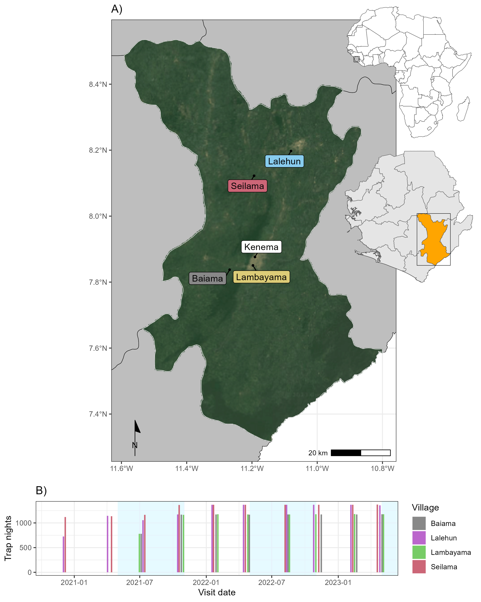

**Figure 1. A)** Location of village study sites (coloured labels), in Eastern Sierra Leone, major cities are shown with white labels. The inset map shows the location of Sierra Leone in West Africa. **B)** Number of trap nights obtained from each study village, blue shaded regions represent the rainy season in Sierra Leone.

## Description of rodent detection and species community structure

Adequacy of sampling effort was assessed using species accumulation curves produced for each village study site and each land use type within a village study site (Supplementary Figure 3), suggesting sufficient effort to detect the expected rodent species within these categories. We constructed detection/non-detection histories for each grid cell and rodent species, assigning “1” when the species was detected and “0” otherwise. We describe species communities at multiple spatial scales. First, all species identified across all village sites and land use types. Second, all species identified within a village study site. Third, all species identified within a single land use type within a single village study site. We report species richness and Shannon diversity at these different spatial scales.

## Estimating the effect of land use on species occurrence and richness

To adjust for differential probabilities of detection that may be driven by environmental conditions and trapping effort during the trapping study and between species, we use a Bayesian spatial latent factor multi-species occupancy model that incorporates residual species correlations, imperfect detection and spatial autocorrelation. Variable selection was informed by a pre-specified conceptual model (Supplementary Figure 4). Models were defined using the sfMsPGOcc function in the spOccupancy package in the R statistical computing language (Doser et al. 2022). This approach defines the true presence or absence ($​_{z}$) of a species ($​_{i}$), at grid cell ($​_{j}$) as arising from a Bernoulli process (Equation 1.). Where $ψ_{j}$ is the probability of occurrence of a species at a grid cell. This is modelled using a logit link where $β_{i}$ are the species-specific regression coefficients of the site-specific covariates ($x_{j}^{⊤}$) and a latent process ${\text{w}}_{i,j}^{*}$. This latent process incorporates residual species correlations through a small number of latent spatial factors and latent variables representing unmeasured grid cell covariates (Equation 2.). Latent spatial factors account for spatial autocorrelation using a Nearest Neighbour Gaussian Process.

$$z_{i,j}∼Bernoulli\left(ψ_{i,j}\right)$$

$$logit\left(ψ_{i,j}\right)=x_{j}^{⊤}β_{i}+{\text{w}}_{i,j}^{*}$$

The species-specific regression coefficients ($β_{i}$) are specified as random effects arising from a common community level distribution (Equation 3.). Where $μ_{β}$ represents the community level mean effect for each occurrence covariate effect and $T_{β}$ is a diagonal matrix representing the variability of these among the species in the community.

$$β_{i}∼\text{Normal}\left(μ_{β},T_{β}\right)$$

The detection component estimates the unobserved $z_{i,j}$. Here, $y_{i,j,k}$ is the observed detection or non-detection of a species $i$, at site $j$, during replicate $k$ (Equation 4.). This is approached as arising from a Bernoulli process conditional on the true latent occurrence process $p_{i,j,k}$. The probability of a species being detected at a grid cell, during a replicate (given it is present at grid cell $j$), is a function of grid cell and replicate specific covariates $v$ and a set of species-specific regression coefficients $α_{i}$ (Equation 5.).

$$y_{i,j,k}∼Bernoulli\left(p_{i,j,k}z_{i,j}\right)$$

$$logit\left(p_{i,j,k}\right)=v_{i,j,k}^{⊤}α_{i}$$

Similarly to Equation 3., these coefficients are specified as random effects arising from a common community level distribution, where $μ_{α}$ represents the community level mean effect for each detection covariate effect and $T_{α}$ is a diagonal matrix representing the variability of these among species in the community (Equation 6.).

$$α_{i}∼\text{Normal}\left(μ_{α},T_{α}\right)$$

Minimally informative priors were specified for community and species level coefficients ( $α$ and $β$, a normal prior of mean = 0, variance = 2.72) and for community level occurrence and detection variance parameters ( $T_{α}$ and $T_{β}$, 0.1 for the scale and shape parameters of the inverse Gamma prior).

We included covariates in the model based on a pre-specified conceptual model and after assessing for co-linearity (defined as strong correlation >0.8) among variables. Continuous variables were standardised by scaling values between 0-1. The fully specified model is defined in Equation 7 and 8 and using a single latent spatial factor.

$$\text{Probability of occurrence}∼\text{Land use type}+\text{Village}+\text{scale}\left(\text{Distance to permanent structure}\right)+\text{scale}\left(\text{Elevation}\right)$$

$$\text{Probability of detection}∼\text{scale}\left(\text{Monthly precipitation}\right)+\text{Moon fraction}+\text{scale}\left(\text{Number of trap nights}\right)$$

Model checks, including mixing patterns of the MCMC sampler and posterior predictive checks were performed as an assessment of goodness of fit. Bayesian p-values were produced at the community level and species level with values greater than 0.1 and less than 0.9 suggestive of adequate model fit. The Widely Applicable Information Criterion (WAIC) was used to guide final model selection (Watanabe 2010). Using this model, we estimate occupancy probability for each species in different land use types. Only estimates for species with at least 25 detections are included to avoid inference from limited data.

We drew posterior samples from the most parsimonious Bayesian occupancy model incorporating spatial autocorrelation to estimate the probability of occurrence of a species within a trapping grid cell (see Supplementary Text 4. for model selection).

## Co-occurrence of *Mastomys natalensis* with sympatric species

To investigate the presence of competitive exclusion of the primary reservoir of Lassa fever by other rodent species within these communities we examined the correlation of the probability of occupancy of species pairs. The predicted probability of occupancy at each of the grid cells from our spatial multi-species occupancy model was obtained. We stratified these by land use type and calculated the Spearman rank correlation coefficient ($ρ$), conducting a two-sided test for statistical significance with a null hypothesis of no correlation between the probability of occupancy for these species. We constrain this analysis to species pairs that were detected in the land use setting in the observed data informing our model to limit inference from sparse data. Further, due to multiple statistical tests we use a conservative value of statistical significance where *p* <= 0.005 represents a statistically significant association to minimise the reporting of false positive associations (Benjamin et al. 2018). A statistically significant positive correlation was interpreted as species one being more likely to occur in a grid cell of the specific land use type if species two were present. A statistically significant negative correlation was interpreted as species one being less likely to occur in a grid cell of the specific land use type if species two were present. The causal mechanism and direction behind any observed correlations cannot be inferred from our current analysis.

# Results

## Rodent detection and species community structure

During the study period 684 individuals were detected from 43,266 trap-nights across the four village study sites (1.6% trap-success (TS)). The greatest number of individuals, highest species richness and Shannon diversity values were obtained in the agricultural areas, meanwhile, TS was greatest within village settings (i.e., within and outside of permanent structures) (Table 1). The Seilama study site had the highest overall TS, species’ richness and Shannon diversity and unlike the three other study sites had the greatest TS in agricultural areas. Species richness in Seilama was twice that of the peri-urban village study site (Lambayama) and had high Shannon diversity across all land use types. The sole peri-urban village study site (Lambayama) located within the expanding boundaries of Kenema city, had the lowest species’ richness and Shannon diversity with the majority of rodents detected within the village area.

Table 1. The number of trapped individuals (N), the number of trap nights (TN), trap-success (TS %), species richness and Shannon diversity by village and landuse type.

| Village | Land use | N | TN (TS %) | Species richness | Shannon diversity |
| --- | --- | --- | --- | --- | --- |
| All villages |  |  |  |  |  |
|  | Village | 261 | 11516 (2.3%) | 12 | 1.67 |
|  | Agriculture | 379 | 26400 (1.4%) | 17 | 2.19 |
|  | Forest | 44 | 5350 (0.8%) | 10 | 1.78 |
| Baiama |  |  |  |  |  |
|  | Village | 73 | 2716 (2.7%) | 8 | 1.11 |
|  | Agriculture | 45 | 4696 (1%) | 9 | 1.94 |
|  | Forest | 3 | 1568 (0.2%) | 2 | 0.64 |
|  | Combined | 121 | 8980 (1.3%) | 12 | 1.73 |
| Lalehun |  |  |  |  |  |
|  | Village | 54 | 2824 (1.9%) | 9 | 1.65 |
|  | Agriculture | 98 | 7608 (1.3%) | 13 | 2.18 |
|  | Forest | 5 | 1862 (0.3%) | 3 | 1.05 |
|  | Combined | 157 | 12294 (1.3%) | 13 | 2.21 |
| Lambayama |  |  |  |  |  |
|  | Village | 93 | 2736 (3.4%) | 4 | 0.42 |
|  | Agriculture | 50 | 6260 (0.8%) | 6 | 1.19 |
|  | Combined | 143 | 8996 (1.6%) | 6 | 1.03 |
| Seilama |  |  |  |  |  |
|  | Village | 41 | 3240 (1.3%) | 8 | 1.54 |
|  | Agriculture | 186 | 7836 (2.4%) | 13 | 1.97 |
|  | Forest | 36 | 1920 (1.9%) | 8 | 1.51 |
|  | Combined | 263 | 12996 (2%) | 14 | 2.07 |

The most commonly detected rodent species across all land use types was *M. natalensis* (N = 113, 16.5%), followed by *Praomys rostratus* (N = 102, 14.9%), *M. musculus* (N = 90, 13.2%), *R. rattus* (N = 88, 12.9%) and *Lophuromys sikapusi* (N = 57, 8.3%). The insectivorous shrew species *Crocidura olivieri* was the most commonly detected non-rodent species (N = 105, 15.4%). *Mastomys natalensis* and *R. rattus* were detected at all village study sites, although *M. natalensis* was not detected in areas (Figure 2.). The invasive rodent species *M. musculus* was only detected in the Lambayama study site. The detection rate (the number of individuals detected per 1,000 TN) varied by species, landuse type and village study site. The greatest rate of detection was for *M. musculus* in the Lambayama village study site, with the other commensal species *M. natalensis* and *R. rattus* having high detection rates across multiple village study sites within village land use types. *P. rostratus.* had the highest detection rates in forest and agricultural areas.

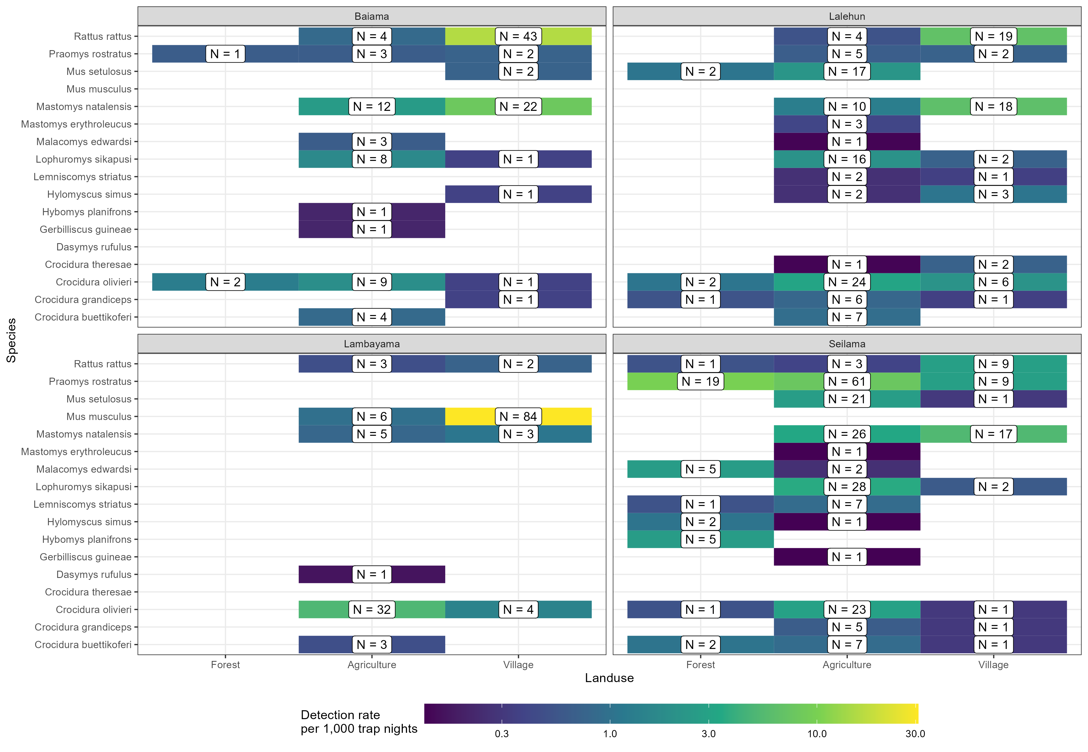

**Figure 2.** Standardised detection rate of rodent species in land use types. The plots are panelled by village study site. The absolute number of detections of each species in each land use type at each study site is shown in the label. The colour of the tile corresponds to the detection rate per 1,000 trap nights.

There was some observed variation in species richness by season. Although, the prevalence of a species (measured as the rate of detections per 1,000 TN), not accounting for incomplete detection, did not show a single trend for all species (Supplementary Figure 5A). *Mus musculus* had a greater detection rate in the rainy season than dry. Conversely, *L. sikapusi*, and *Mus setulosus* had greater detection rates in the dry season. The other species had similar detection rates across both seasons. There was some further variation when stratified by landuse type. *Mastomys natalensis* had greater detection rates in villages compared to agricultural areas in the rainy season while in the dry season it was detected at similar rates in village and agricultural areas (Supplementary Material 5B). *Praomys rostratus* had greater detection rates in forests during the dry season compared with the rainy season. No other species had important variations by season stratified by land use type.

## Estimating the effect of land use on species occurrence and richness

We found three patterns of probability of occurrence ($ψ$) within a trapping grid cell for the seven included species (Figure 3. and, marginal effects of the remaining parameters are shown in Supplementary Figure 6A-E). First, *M. natalensis*, *R. rattus* and *M. musculus* had greatest probabilities of occurrence in villages with lower occurrence probabilities in agricultural and forest areas. *Mastomys natalensis* differed from the two commensal, invasive species (*R. rattus* and *M. musculus*) as their probability of occurrence in agricultural settings was generally high. Second, *P. rostratus* had high probability of occurrence in forests with lower probabilities in agricultural areas and villages. Finally, *C. olivieri*, *L. sikapusi* and *M. setulosus* had their highest probabilities of occurrence in agricultural areas with lower probabilities of occurrence in forests and villages. No species showed high probability of occurrence across all land use types, consistent with species being adapted to distinct ecological niches.

The probability of occurrence within a trapping grid cell of some species within the same land use types showed wide variability for some species. For example, the narrow range of probabilities for *M. natalensis* in forests (0-13%) is suggestive that the probability of this species occurring within forests is low. The wide range of probabilities for some species, such as, *P. rostratus* in agricultural areas, between 0-90% is suggestive that in some agricultural grid cells the probability of occurrence was low while in others it was highly likely to occur.

To further explore this we stratified village study sites by human population density into rural and peri-urban (rural <= 500 individuals per 1km2) (Figure 3.). The probability of occurrence of *M. natalensis* was importantly different, with high probability of occurrence in both agricultural and village settings in rural areas but substantially lower probability in peri-urban study sites. The same pattern was observed for *R. rattus*. For the rodent species predicted to have lower probability of occurrence in village settings, namely, *P. rostratus*, *L. sikapusi* and *M. setulosus* probabilities of occurrence were greater in all landuse types in rural areas compared to peri-urban areas. Shrew species were predicted to have similar probabilities of occurrence in rural and peri-urban areas. In contrast, *M. musculus* was predicted to have a low probability of occurrence in all landuse types in rural areas, with high values only for village settings in peri-urban areas. The occurrence probabilities for the three commensal species (*M. natalensis*, *R. rattus* and *M. musculus*) suggest that competition may be reducing the occurrence of *M. natalensis* and *R. rattus* in the presence of *M. musculus* as in it’s absence these two species have high occurrence probabilities in villages.

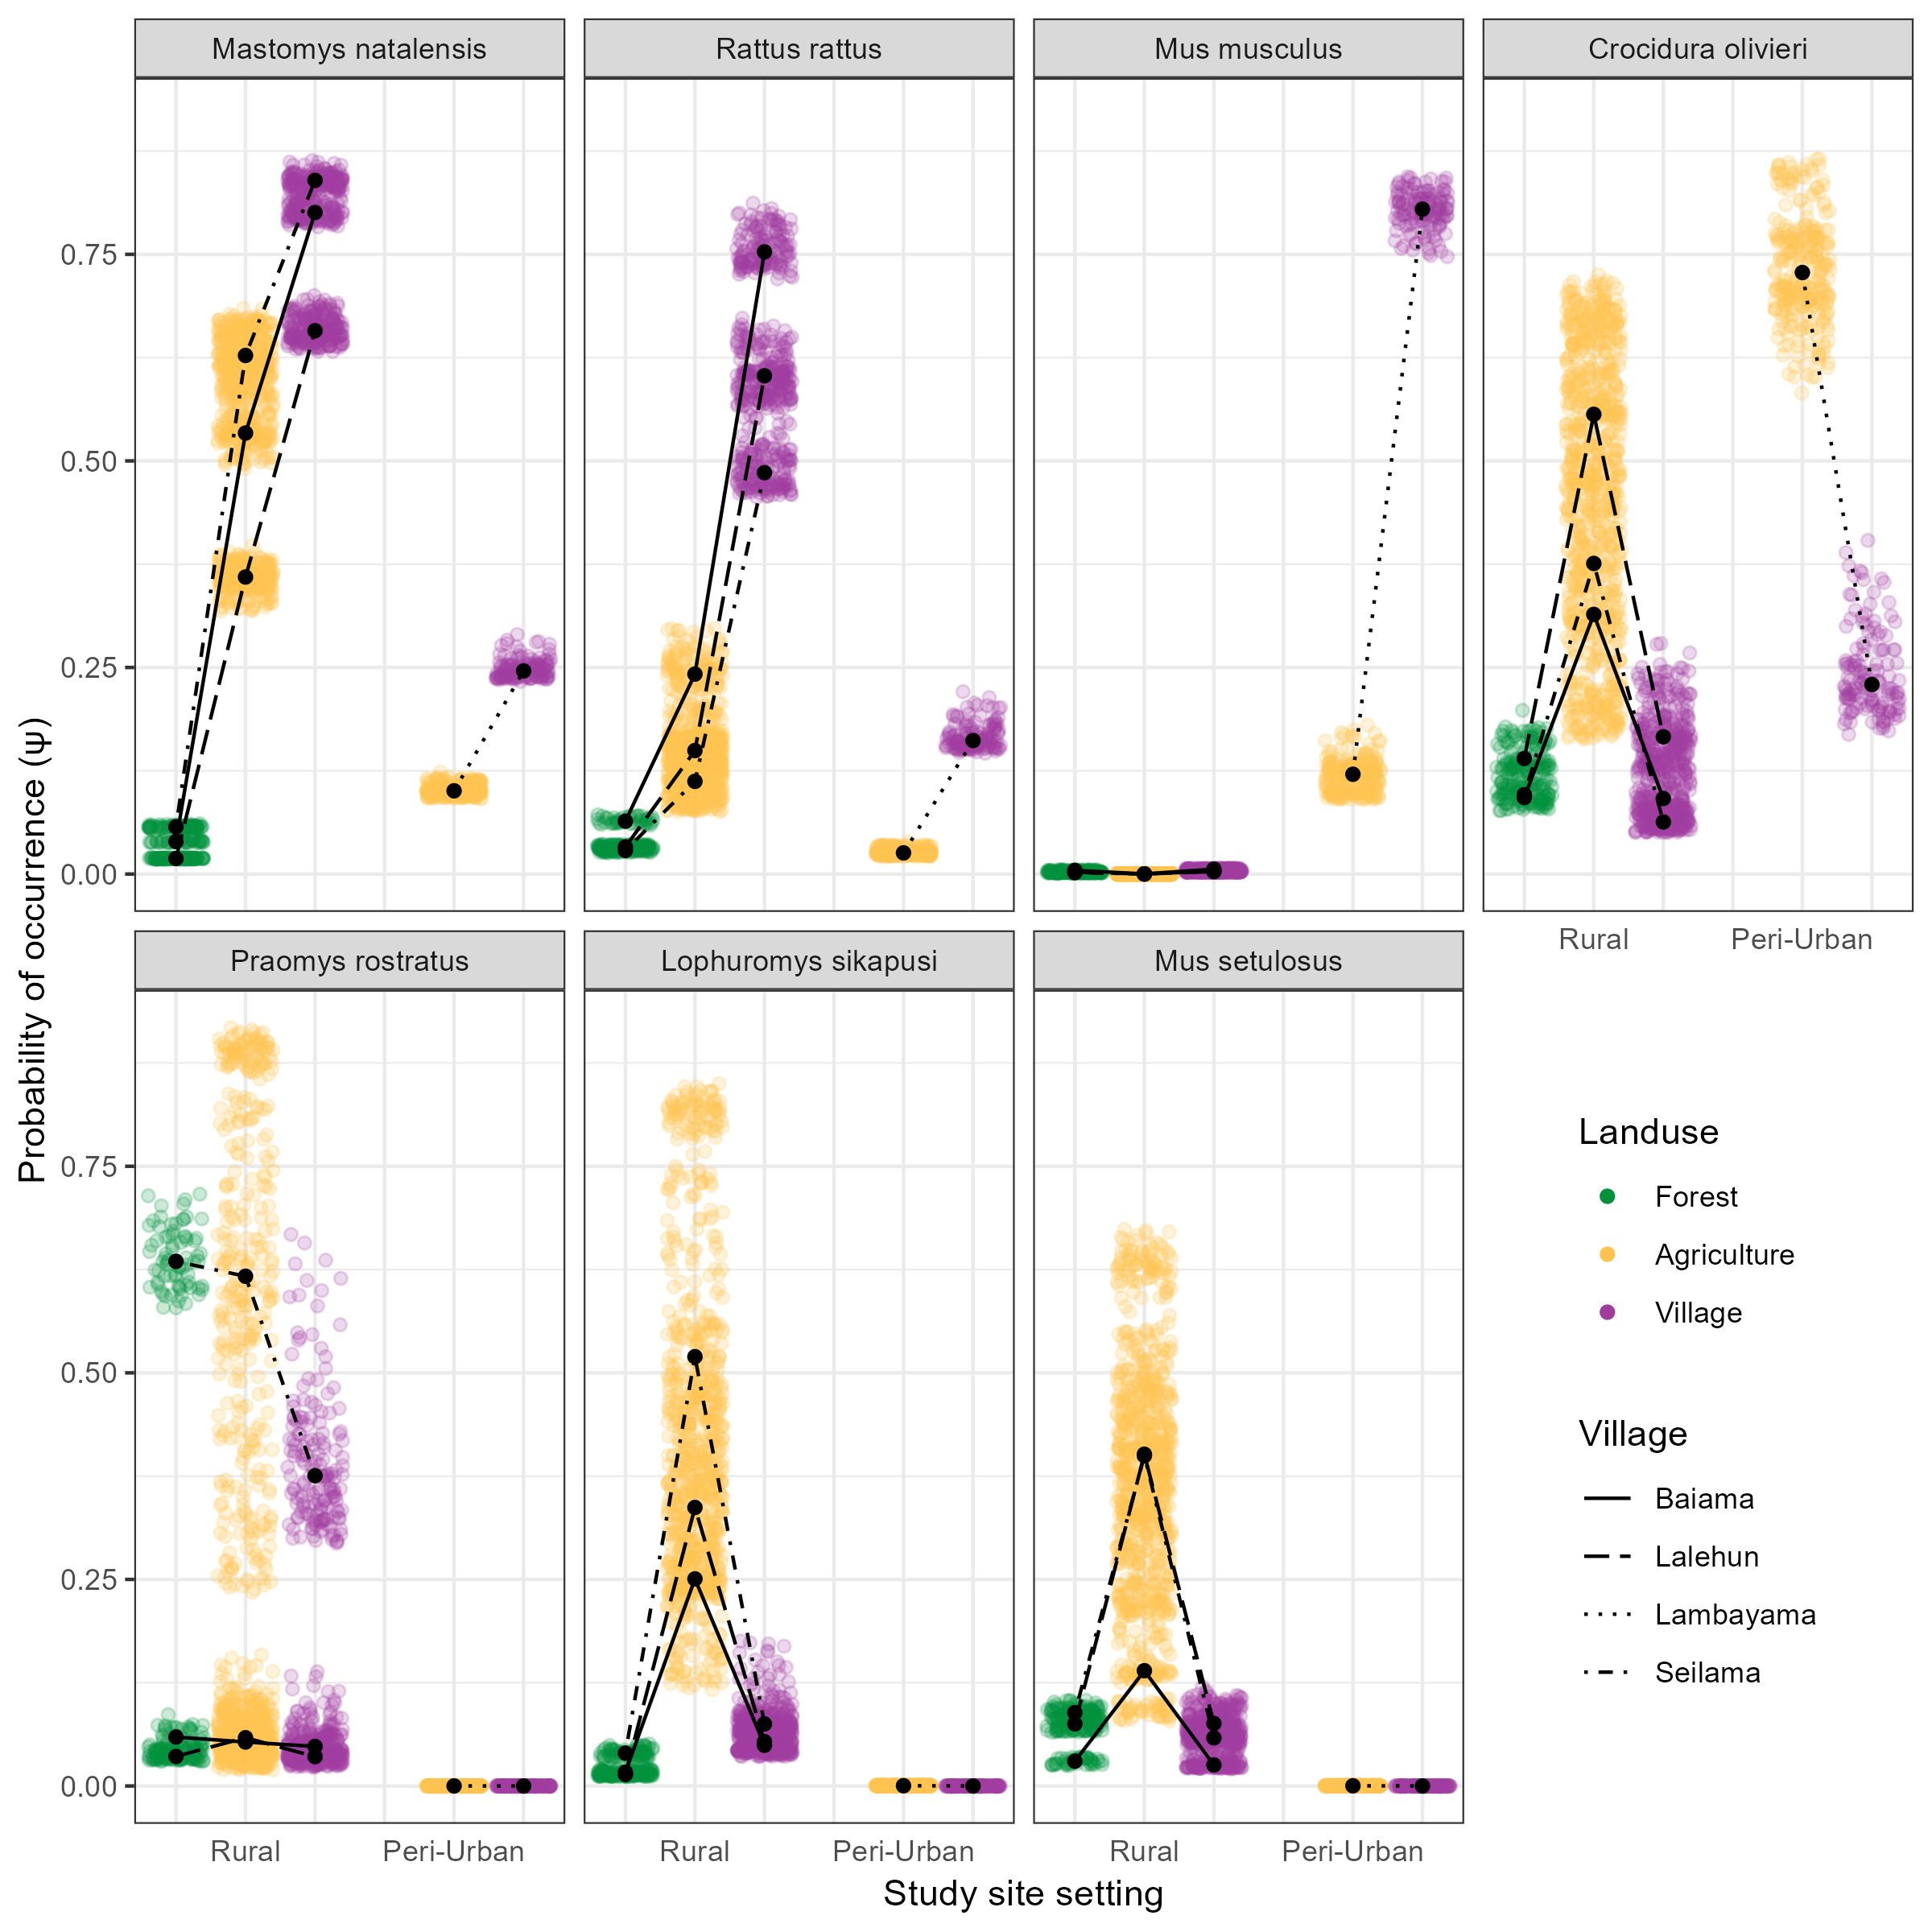

**Figure 3.** Probability of species occurrence ($ψ$) across a land use gradient stratified by rural and peri-urban village study sites for the seven rodent and shrew species. Each coloured point is the median of the predicted probability of occurrence for a species obtained from the posterior distribution at a trapping grid cell, colours correspond to the different land use types. Predictions were obtained for each of the 2,068 trapping grid cells. Black points represent the median probability of occurrence within a land use type grouped by village, with lines connecting within villages for different land use types.

## Co-occurrence of species within land use types

Our tests for species correlations supported that the local spatial distribution of *M. natalensis* is regulated by biotic interactions with co-occurring species (Figure 4.). We observed that in land use types where both *M. natalensis* and *M. musculus* co-occurred the presence of one species led to a reduction in the probability of occurrence at a grid cell level of the other with a statistically significant negative correlation observed in agricultural (Spearman’s $ρ$ = -0.67, *p* < 0.001) and village ( $ρ$ = -0.35, *p* < 0.001) settings. This negative relationship was not observed between *M. natalensis* and the other commensal, invasive rodent *R. rattus*, where a positive correlation between probabilities of occurrences in both agricultural ( $ρ$ = 0.51, *p* < 0.001) and village ( $ρ$ = 0.36, *p* < 0.001) settings was observed. Generally, within villages, high probabilities for the presence of *M. musculus* was associated with lower probabilities for all other rodent species. This was not replicated for *M. natalensis* and *R. rattus*, which were positively associated with the co-occurrence of other native rodent species *P. rostratus*, *L. sikapusi* and *M. setulosus*. Generally, across all landuse types, the presence of the shrew species *C. olivieri* had a negative correlation with the presence of rodent species’.

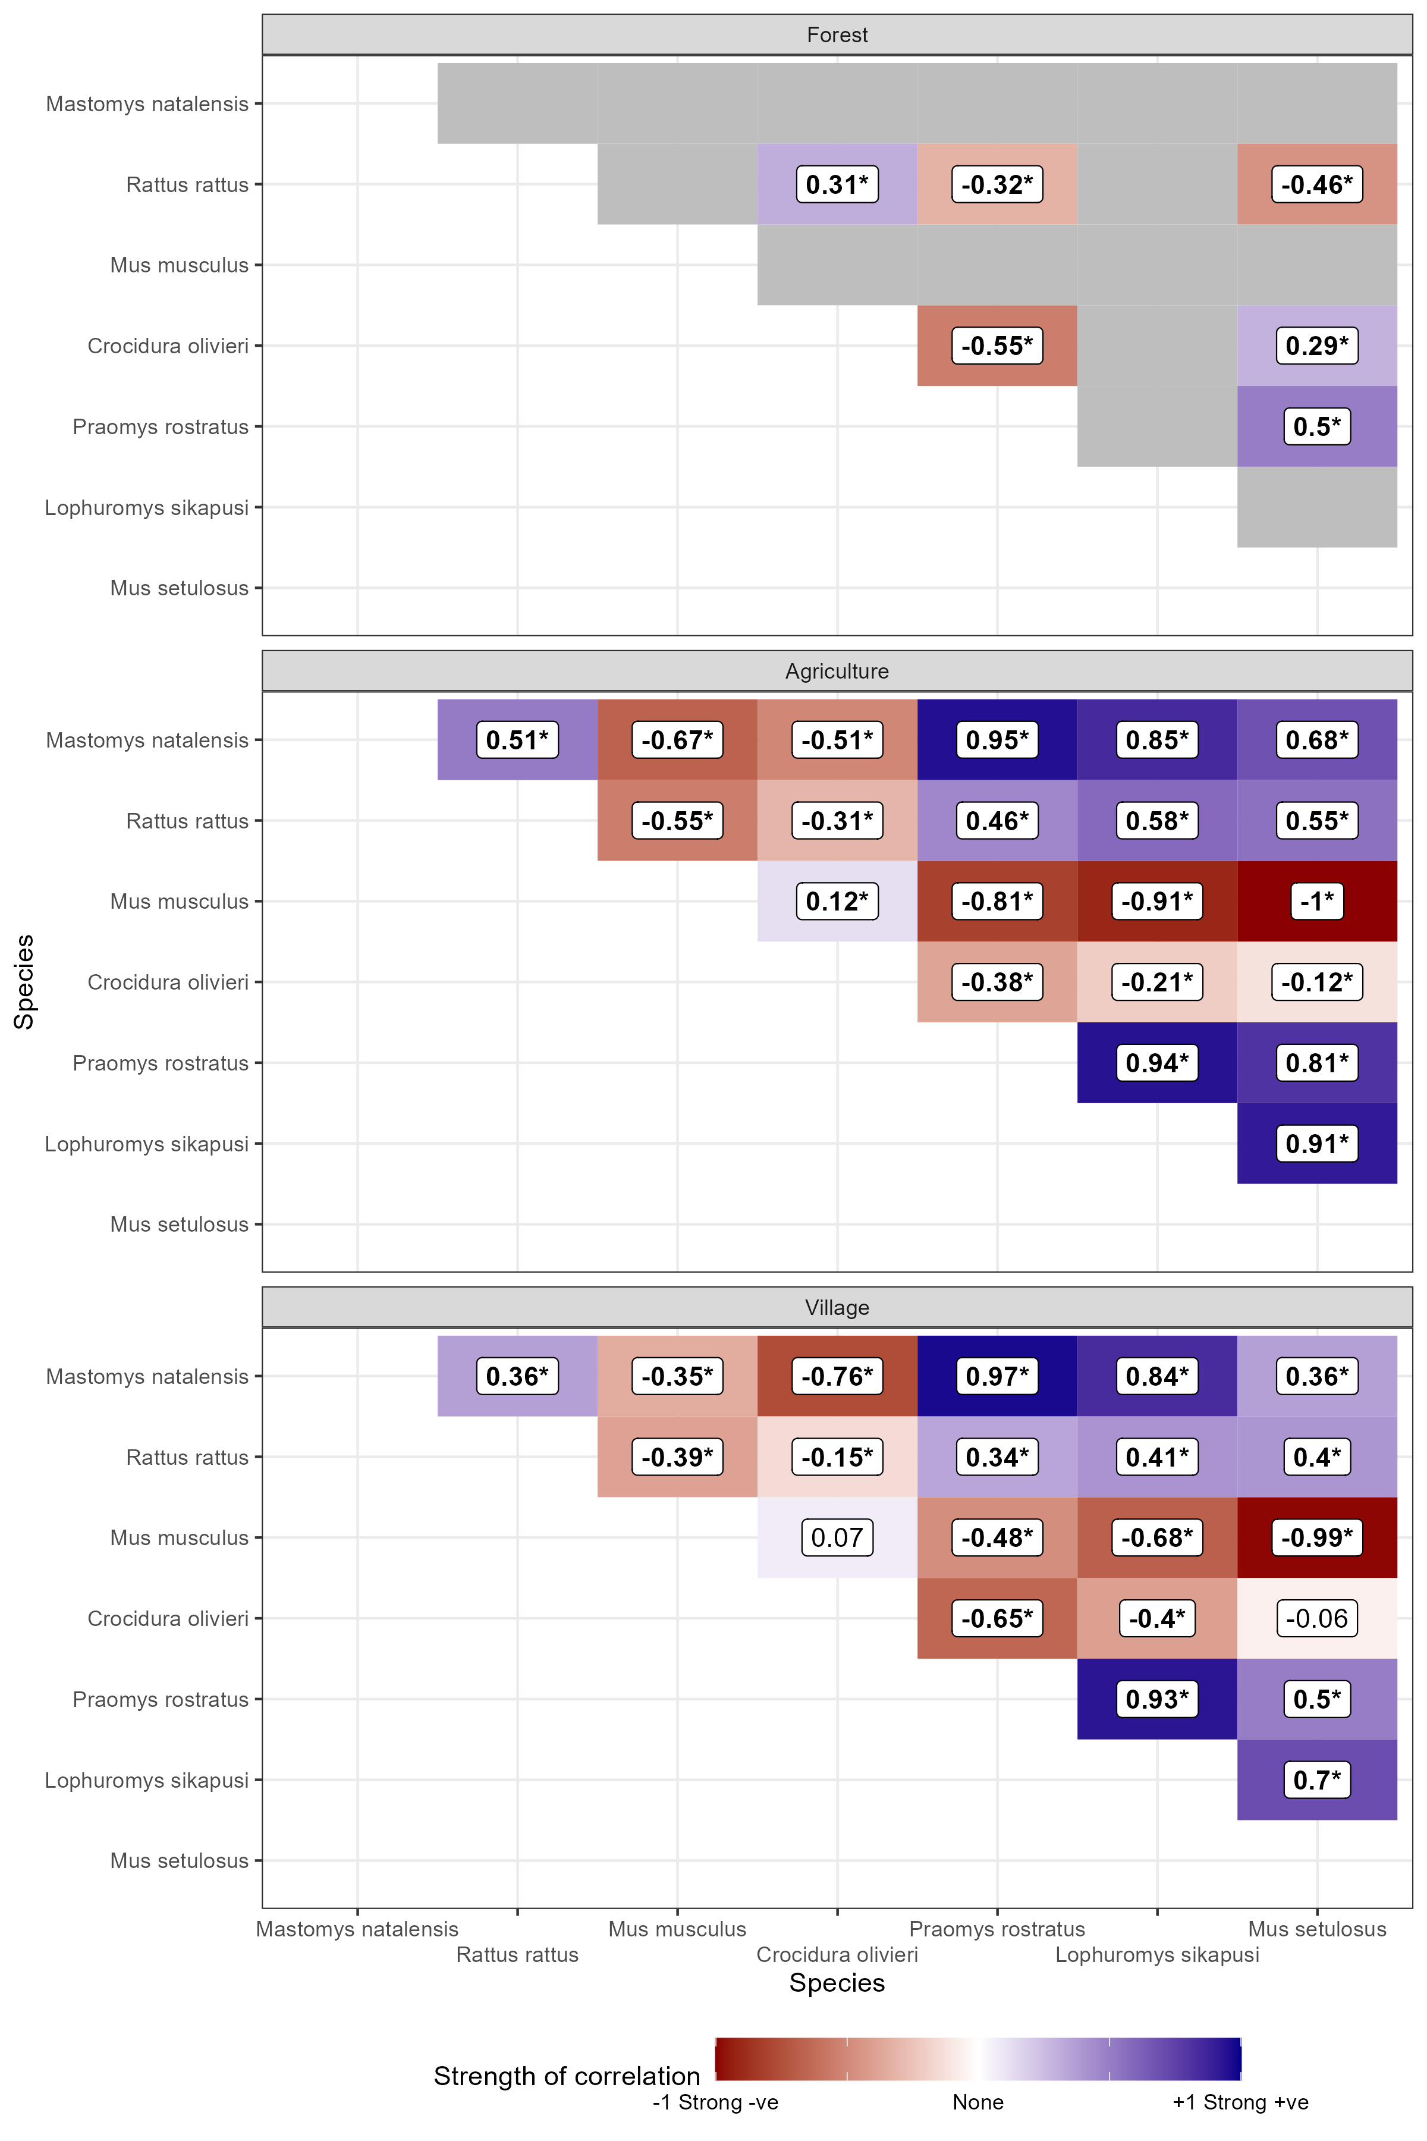

**Figure 4.** Spearman’s rank correlations for the modelled probability of occurrence of species pairs in different land use types. Positive values (blue shades) represent positive correlation coefficients between the occurrence of two species. Negative values (red shades) represent negative correlation between the occurrence of two species. Numbers in bold typeface and indicated with an asterisk () are statistically significant at a level of p* <= 0.005. Grey tiles are used where no detections of the species pair in the landuse type were observed and therefore excluded from analysis.

# Discussion

Our analysis presented the results of a systematic small-mammal trapping study in Eastern Sierra Leone investigating rodent species communities across a land use gradient in a Lassa fever endemic region. First, we found similar species richness and diversity to rodent sampling from other regions of the Lassa fever endemic zone in Guinea, Nigeria and Sierra Leone (Fichet-Calvet et al. 2014; Olayemi et al. 2018; Bangura et al. 2021). We found that species richness and diversity was highest in agricultural land use settings with reduced richness in both forests and villages. There was important variation of species richness and diversity between different land use types in peri-urban and rural settings. Second, the primary host of LASV, *M. natalensis* showed a response to human dominated land use with the highest probability of occupancy in villages, followed by agricultural settings and likely absence from forests. We observed similar patterns of occurrence for the two invasive, commensal, rodent species *M. musculus* and *R. rattus*. Following stratification by human population density, we found that the probability of occurrence of *M. natalensis* was lower in peri-urban settings where *M. musculus* has replaced *M. natalensis* as the dominant commensal rodent species. Finally, we assessed for correlations in the probability of co-occurrence. We found a negative association between the probability of occupancy of *M. natalensis* and *M. musculus* within villages that could have important implications for the understanding of risk of spillover of Lassa fever in endemic regions.

## Rodent communities are associated with land use type

Rodent species richness was found to be greatest in agricultural settings. In these settings both synanthropic and non-synanthropic species were found, resulting in increased species richness and diversity. Agricultural land use may thus provide greater opportunity for LASV transmission among species within diverse rodent communities. There is some evidence for a role of the wider rodent community in LASV transmission. Current or prior infection with LASV (through detection of virus or antibodies), has been identified in 11 additional small mammal species, whether these represent incidental infections or competent chains of viral transmission are not known (Monath et al. 1974; Demby et al. 2001; Fichet-Calvet et al. 2014; Olayemi et al. 2016; Simons et al. 2023). It is possible be that viral sharing within rodent communities is greatest in these species rich agricultural settings, allowing introduction or re-introduction of the pathogen into isolated commensal species populations following extinction (Bordes, Blasdell, and Morand 2015). This may be particularly important for maintaining viral persistence in spatially isolated *M. natalensis* populations, as rapid depletion of susceptible individuals is expected in isolated well mixed populations (Goyens et al. 2013). The spatial isolation of communities of this species is support by this study and previous studies finding absence within forested regions and limited geographic dispersal (H. Leirs, Verheyen, and Verhagen 1996; Denys et al. 2005; Mariën et al. 2018). The role of the wider rodent community in translocating LASV between *M. natalensis* populations needs further investigation.

We did not observe that *M. natalensis* was more prevalent in village settings during the dry season, as has been reported from elsewhere in Sierra Leone and Guinea (Bangura et al. 2021; Fichet-Calvet et al. 2007). Our finding of similar or increased prevalence of *M. natalensis* between seasons, not accounting for imperfect detection, were consistent across our village study sites. It is possible that in this region different agricultural processes or food storage practices by village communities results in different rodent behaviour to elsewhere in its range (Kelly et al. 2013; Leach et al. 2017). Alternatively, increased trap-shyness during periods of increased abundance may mask replication of previous findings. Additional rodent community studies, incorporating local human community behaviour and practices, over longer time periods, across different geographic regions, would be informative to ascertain seasonal habitat preferences of these rodents. It has been suggested that prevalence of *M. natalensis* within households is the proximal driver of the risk of Lassa fever spillover into human populations driven by the potentially increased rate of human-rodent host contact within households (Bonwitt et al. 2017; Mariën et al. 2020). Therefore, migration from species rich agricultural settings to within households by hosts of LASV may be an important component of Lassa fever outbreaks.

## Evidence for biotic interactions shaping patterns of rodent species diversity

The finding that rodent species displayed a segregation into distinct ecological niches of human dominated (village and agriculture) or non-human dominated (forest) land use types suggests an important role for biotic factors in species occurrence. The high predicted occupancy of both *M. natalensis* and *R. rattus* in human dominated landscapes and positive correlation in co-occurrence is consistent with another study conducted elsewhere in Sierra Leone (Bangura et al. 2021). This suggests that these two rodent species do not directly compete for resources and that the presence of one species does not preclude the other. This may not be true for interactions between *M. musculus* with both *R. rattus* and *M. natalensis*. The probability of occurrence of *M. musculus* within villages was negatively correlated with the co-occurrence of both *M. natalensis* and *R. rattus*. *Mus musculus* was also absent in village land use types in rural settings where *R. rattus* and *M. natalensis* had high probabilities of occurring. This trend was replicated for *M. musculus* with all other rodent species in village settings. It is not possible to ascertain from the current study whether M. musculus is expanding into rural settings and what effect this may have on rodent communities and LASV transmission. To identify the causal processes of changes in rodent species community structures in response to invasive species’ range expansion longer term monitoring of rodent communities would be beneficial, similar to that conducted in Senegal (Dalecky et al. 2015).

## Benefits and challenges of systemic rodent community sampling

Systematic investigation of rodent communities requires a greater amount of sampling effort compared to targeted sampling of a rodent species’ within selected habitats. In this study we had a low overall trap success rate compared to studies focused on synanthropic rodent species’ (Bangura et al. 2021; Olayemi et al. 2018; Happi et al. 2022). Our obtained trap success rate of 3.3% within villages is comparable to the 3% obtained from a study conducted in Bo, Sierra Leone, but is substantially lower than the 17% and 14% reported from Nigeria and Guinea respectively (Bangura et al. 2021; Happi et al. 2022; Fichet-Calvet et al. 2007). Detection rates of *M. natalensis* within its Western radiation of Nigeria, Guinea and Sierra Leone are also lower than that obtained from Tanzania where trap success rates around 24% are reported from agricultural settings (Mulungu et al. 2013). Whether this represents different behaviour within the species based on food availability is not known, although environmental food availability is known to be associated with trap-shyness (Taylor, Hammond, and Quy 1974; Stryjek, Kalinowski, and Parsons 2019). Despite the increased trapping effort required to obtain the necessary number detections for statistical inference, adopting this approach will mitigate some of the biases in rodent species and viral detection introduced by targeted sampling.

Comparison between studies using different sampling techniques and study designs presents several challenges. Previous studies on rodent communities in the Lassa fever endemic region have used trap success rates as an indirect measure of rodent abundance in the absence of capture-mark-recapture studies (Fichet-Calvet et al. 2009; Olayemi et al. 2018; Bangura et al. 2021). Our analysis, using a model incorporating imperfect detection, suggests estimating abundance from trap success may not be applicable across different land use types and species (Supplementary Figure 6C). For example, we found that the probability of detection of *M. musculus* and *R. rattus* were higher than native species given a consistent amount of trapping effort. Detection rate as a measure of relative abundance has been shown to poorly replicate using combined live-trapping and camera-trapping approaches in the USA (Parsons, Clark, and Kays 2022). Drivers of variability in detection may include trap-shyness (i.e., neophobia) of non-synanthropic species, the availability of resources in the local environment and the placement locations of traps, the contribution of these factors on detection require further study in our setting (Stryjek, Kalinowski, and Parsons 2019). Improved harmonisation of rodent sampling designs particularly incorporating systematic community sampling will facilitate direct comparison of rodent species communities and pathogen prevalence across the Lassa fever endemic region.

There are several limitations to the current study. Rodent sampling was limited to a relatively short period, less than three years, it is possible that rodent populations in these settings have important multi-year variations in abundance that could not be captured in our model and therefore the probability of occurrence may be under-estimated for species that were at low abundance during our survey period. Sampling over a longer time period would allow any potential temporal changes in probability of occurrence to be better identified. Similarly, land use in Sierra Leone, particularly agricultural land, goes through multi-year cycles of use. It would be informative to study a single location in the transition from forested, to agricultural, to long term fallow and to degraded forest land use to better characterise changes in rodent communities within these settings of land management. Unobserved characteristics of our study villages also likely contributed to the composition of rodent communities, suggested by the wide posterior distributions for some rodent species, expanding this study to sample more villages would be beneficial to allow further generalisation of our findings over the wider region.

## Implications for understanding the risk of Lassa fever spillover

The lower levels of occurrence of *M. natalensis* in agricultural and forest land use is consistent with increasing evidence of LASV prevalence heterogeneity across the endemic region (Mariën et al. 2020). In some village communities within the endemic region no evidence of current LASV transmission has been observed within the rodent populations, despite prior human cases or serological evidence of outbreaks, suggesting important temporal and spatial variation in pathogen prevalence (Bangura et al. 2021; McCormick et al. 1987; Leski et al. 2015). As discussed above it may be that transmission among the rodent community is short lived with rapid local extinction of LASV (Goyens et al. 2013). This phenomena may implicate non-*M. natalensis* species as being important for transferring the pathogen between communities of *M. natalensis* resident in villages separated by forest, leading to pathogen re-introduction. Several species found to occur in forest settings have been found to have antibodies against LASV, namely *Praomys rostratus*, *M. setulosus*, *Malacomys edwardsi* and *L. striatus* (Monath et al. 1974; Demby et al. 2001; Fichet-Calvet et al. 2014; Olayemi et al. 2016; Simons et al. 2023). To understand the temporal and spatial variability in LASV prevalence rodent sampling across the wider land use gradient that solely villages are required.

Finally, current disease models of Lassa fever risk do not account for the involvement of multiple rodent species or biotic interactions between species (Basinski et al. 2021; Mylne et al. 2015; Olugasa et al. 2014; Redding et al. 2016; Fichet-Calvet and Rogers 2009; Klitting et al. 2022). Our finding of interactions between *M. natalensis* and primarily *M. musculus* may indicate that Lassa fever risk could be reduced in settings where *M. musculus* is present. Further research exploring the competence of *M. musculus* as a host of LASV are required, as evidence of prior infection, through serological assays has been reported (Demby et al. 2001). If *M. musculus* is not a competent host of LASV this may go some way to explain why Lassa fever is more typically reported from rural locations in the endemic region rather than cities, where this invasive species may have displaced more competent viral hosts. Further work systematically sampling across the urban-rural gradient will be required to test this hypothesis which will have implications for estimates of future Lassa fever risk. West Africa continues to undergo large population growth and rapid urbanisation, the expansion of *M. musculus* may therefore moderate the risk of increasing numbers of Lassa fever outbreaks.

# Authors’ contributions

DS, RG, DW-J, RK and KEJ conceived the ideas and designed the methodology. DS, UB, DiS, JL, JK, MJ, MD, JosL and RA collected the data. DS and RG analysed the data. DS, RG and KEJ interpreted the analysis. DS led the writing of the manuscript. RG, DW-J, RK and KEJ contributed critically to the drafts. All authors gave final approval for publication.

# Statement on inclusion

This study brings together authors from several countries, including scientists based in the country where the study was carried out. All authors were engaged early on with the research and study design to ensure that the diverse sets of perspectives they represent was considered. Literature published by scientists from the study country and wider region was cited. Study protocols were discussed with local scientists for appropriateness of design. Consultations were held with community leaders of the study villages and the wider region prior to finalising the study design and enrolment of sites into the study.

# Acknowledgments

The authors would like to thank Jeff Doser, the developer of the spOccupancy package for assistance with optimising the model construction and fitting process.

# Conflict of interest

All authors report no financial conflicts of interest.

# Data availability

Data are available from the Zenodo file repository …

All R scripts to reproduce the analysis are available from an archived GitHub repository …

# References

Agbonlahor, Dennis E., George O. Akpede, Christian T. Happi, and Oyewale Tomori. 2021. “52 Years of Lassa Fever Outbreaks in Nigeria, 1969–2020: An Epidemiologic Analysis of the Temporal and Spatial Trends.” *The American Journal of Tropical Medicine and Hygiene* -1 (August). <https://doi.org/10.4269/ajtmh.20-1160>.

Altschul, S. F., W. Gish, W. Miller, E. W. Myers, and D. J. Lipman. 1990. “Basic Local Alignment Search Tool.” *Journal of Molecular Biology* 215 (3): 403–10. <https://doi.org/10.1016/S0022-2836(05)80360-2>.

Arruda, Liã Bárbara, Najmul Haider, Ayodeji Olayemi, David Simons, Deborah Ehichioya, Adesola Yinka-Ogunleye, Rashid Ansumana, et al. 2021. “The Niche of One Health Approaches in Lassa Fever Surveillance and Control.” *Annals of Clinical Microbiology and Antimicrobials* 20 (1): 29. <https://doi.org/10.1186/s12941-021-00431-0>.

Bangura, Umaru, Jacob Buanie, Joyce Lamin, Christopher Davis, Gedeon Ngiala Bongo, Michael Dawson, Rashid Ansumana, et al. 2021. “Lassa Virus Circulation in Small Mammal Populations in Bo District, Sierra Leone.” *BIOLOGY-BASEL* 10 (1). <https://doi.org/10.3390/biology10010028>.

Basinski, Andrew J., Elisabeth Fichet-Calvet, Anna R. Sjodin, Tanner J. Varrelman, Christopher H. Remien, Nathan C. Layman, Brian H. Bird, et al. 2021. “Bridging the Gap: Using Reservoir Ecology and Human Serosurveys to Estimate Lassa Virus Spillover in West Africa.” Edited by Amy Wesolowski. *PLOS Computational Biology* 17 (3): e1008811. <https://doi.org/10.1371/journal.pcbi.1008811>.

Benedek, Ana Maria, and Ioan Sîrbu. 2018. “Responses of Small Mammal Communities to Environment and Agriculture in a Rural Mosaic Landscape.” *Mammalian Biology* 90 (1): 55–65. <https://doi.org/10.1016/j.mambio.2018.02.008>.

Benjamin, Daniel J., James O. Berger, Magnus Johannesson, Brian A. Nosek, E.-J. Wagenmakers, Richard Berk, Kenneth A. Bollen, et al. 2018. “Redefine Statistical Significance.” *Nature Human Behaviour* 2 (1): 6–10. <https://doi.org/10.1038/s41562-017-0189-z>.

Bonner, Phillip Cullison, Wolf-Peter Schmidt, Steven R. Belmain, Babafemi Oshin, Debbie Baglole, and Matthias Borchert. 2007. “[Poor Housing Quality Increases Risk of Rodent Infestation and Lassa Fever in Refugee Camps of Sierra Leone](https://www.ncbi.nlm.nih.gov/pubmed/17620650).” *American Journal of Tropical Medicine & Hygiene* 77 (1): 169–75.

Bonwitt, Jesse, Almudena Mari Sáez, Joseph Lamin, Rashid Ansumana, Michael Dawson, Jacob Buanie, Joyce Lamin, et al. 2017. “At Home with Mastomys and Rattus: Human-Rodent Interactions and Potential for Primary Transmission of Lassa Virus in Domestic Spaces.” *The American Journal of Tropical Medicine and Hygiene* 96 (4): 935–43. <https://doi.org/10.4269/ajtmh.16-0675>.

Bordes, Frédéric, Kim Blasdell, and Serge Morand. 2015. “Transmission Ecology of Rodent-Borne Diseases: New Frontiers.” *Integrative Zoology* 10 (5): 424–35. <https://doi.org/10.1111/1749-4877.12149>.

Cuypers, Laura N, Wim L Cuypers, Amélie Gildemyn-Blomme, Laura Abraham, Senne Aertbeliën, Apia W Massawe, Benny Borremans, Sophie Gryseels, and Herwig Leirs. 2017. “No Evidence for Avoidance of Black Rat Scent by the Presumably Less Competitive Natal Multimammate Mouse in a Choice Experiment.” *African Zoology* 52 (2): 119–23. <https://doi.org/10.1080/15627020.2017.1307139>.

Dalecky, Ambroise, Khalilou Ba, Sylvain Piry, Cedric Lippens, Christophe A. Diagne, Mamadou Kane, Aliou Sow, et al. 2015. “Range Expansion of the Invasive House Mouse Mus Musculus Domesticus in Senegal, West Africa: A Synthesis of Trapping Data over Three Decades, 1983-2014.” *Mammal Review* 45 (3): 176–90. <https://doi.org/10.1111/mam.12043>.

Demby, Austin H., Alphonse Inapogui, Kandeh Kargbo, James Koninga, Kerfalla Kourouma, James Kanu, Mamadi Coulibaly, et al. 2001. “Lassa Fever in Guinea: II. Distribution and Prevalence of Lassa Virus Infection in Small Mammals.” *Vector-Borne and Zoonotic Diseases* 1 (4): 283–97. <https://doi.org/10.1089/15303660160025912>.

Denys, C., E. Lecompte, E. Calvet, M. D. Camara, A. Doré, K. Koulémou, F. Kourouma, et al. 2005. “Community Analysis of Muridae (Mammalia, Rodentia) Diversity in Guinea: A Special Emphasis on Mastomys Species and Lassa Fever Distributions.” In *African Biodiversity*, by Bernhard A. Huber, Bradley J. Sinclair, and Karl-Heinz Lampe, 339–50. Boston, MA: Springer US. <https://doi.org/10.1007/0-387-24320-8_34>.

Doser, Jeffrey W., Andrew O. Finley, Marc Kéry, and Elise F. Zipkin. 2022. “spOccupancy: An r Package for Single-Species, Multi-Species, and Integrated Spatial Occupancy Models.” *Methods in Ecology and Evolution*. <https://doi.org/10.1111/2041-210X.13897>.

Fichet-Calvet, Elisabeth. 2014. “Chapter 5 - Lassa Fever: A Rodent-Human Interaction.” In *The Role of Animals in Emerging Viral Diseases*, edited by Nicholas Johnson, 89–123. Boston: Academic Press. <https://doi.org/10.1016/B978-0-12-405191-1.00005-3>.

Fichet-Calvet, Elisabeth, Beate Becker-Ziaja, Lamine Koivogui, and Stephan Günther. 2014. “Lassa Serology in Natural Populations of Rodents and Horizontal Transmission.” *Vector Borne and Zoonotic Diseases* 14 (9): 665–74. <https://doi.org/10.1089/vbz.2013.1484>.

Fichet-Calvet, Elisabeth, Kekoura Koulemou, Lamine Koivogui, Barre Soropogui, Oumar Sylla, Emilie Lecompte, Stephane Daffis, et al. 2005. “Spatial Distribution of Commensal Rodents in Regions with High and Low Lassa Fever Prevalence in Guinea.” *Belgian Journal of Zoology* 135 (December): 63–67. <https://biblio.naturalsciences.be/associated_publications/bjz/bibliographic-references/ISI_000203706900011>.

Fichet-Calvet, Elisabeth, Emilie Lecompte, Lamine Koivogui, Barré Soropogui, Amadou Doré, Fodé Kourouma, Oumar Sylla, Stéphane Daffis, Kékoura Koulémou, and Jan Ter Meulen. 2007. “Fluctuation of Abundance and Lassa Virus Prevalence in Mastomys Natalensis in Guinea, West Africa.” *Vector Borne and Zoonotic Diseases* 7 (2): 119–28. <https://doi.org/10.1089/vbz.2006.0520>.

Fichet-Calvet, Elisabeth, Emilie Lecompte, Frederic Veyrunes, Patrick Barrière, Violaine Nicolas, and Kékoura Koulémou. 2009. “Diversity and Dynamics in a Community of Small Mammals in Coastal Guinea, West Africa.” *Belgian Journal of Zoology* 139 (2): 93–102. <http://www.vliz.be/nl/open-marien-archief?module=ref&refid=204614>.

Fichet-Calvet, Elisabeth, and David John Rogers. 2009. “Risk Maps of Lassa Fever in West Africa.” *PLOS Neglected Tropical Diseases* 3 (3): e388. <https://doi.org/10.1371/journal.pntd.0000388>.

Garba, Madougou, Ambroise Dalecky, Ibrahima Kadaoure, Mamadou Kane, Karmadine Hima, Sophie Veran, Sama Gagare, et al. 2014. “Spatial Segregation Between Invasive and Native Commensal Rodents in an Urban Environment: A Case Study in Niamey, Niger.” Edited by Jonas Waldenström. *PLoS ONE* 9 (11): e110666. <https://doi.org/10.1371/journal.pone.0110666>.

Gibb, Rory, Lina M. Moses, David W. Redding, and Kate E. Jones. 2017. “Understanding the Cryptic Nature of Lassa Fever in West Africa.” *Pathogens and Global Health* 111 (6): 276–88. <https://doi.org/10.1080/20477724.2017.1369643>.

Gibb, Rory, David W. Redding, Kai Qing Chin, Christl A. Donnelly, Tim M. Blackburn, Tim Newbold, and Kate E. Jones. 2020. “Zoonotic Host Diversity Increases in Human-Dominated Ecosystems.” *Nature* 584 (7821): 398–402. <https://doi.org/10.1038/s41586-020-2562-8>.

Glidden, Caroline K., Nicole Nova, Morgan P. Kain, Katherine M. Lagerstrom, Eloise B. Skinner, Lisa Mandle, Susanne H. Sokolow, et al. 2021. “Human-Mediated Impacts on Biodiversity and the Consequences for Zoonotic Disease Spillover.” *Current Biology* 31 (19): R1342–61. <https://doi.org/10.1016/j.cub.2021.08.070>.

Goyens, J., J. Reijniers, B. Borremans, and H. Leirs. 2013. “Density Thresholds for Mopeia Virus Invasion and Persistence in Its Host Mastomys Natalensis.” *Journal of Theoretical Biology* 317 (January): 55–61. <https://doi.org/10.1016/j.jtbi.2012.09.039>.

Grant, Donald S., Emily J. Engel, Nicole Roberts Yerkes, Lansana Kanneh, James Koninga, Michael A. Gbakie, Foday Alhasan, et al. 2023. “Seroprevalence of Anti-Lassa Virus IgG Antibodies in Three Districts of Sierra Leone: A Cross-Sectional, Population-Based Study.” *PLOS Neglected Tropical Diseases* 17 (2): e0010938. <https://doi.org/10.1371/journal.pntd.0010938>.

Han, Barbara A., John Paul Schmidt, Sarah E. Bowden, and John M. Drake. 2015. “Rodent Reservoirs of Future Zoonotic Diseases.” *Proceedings of the National Academy of Sciences* 112 (22): 7039–44. <https://doi.org/10.1073/pnas.1501598112>.

Happi, Anise N., Testimony J. Olumade, Olusola A. Ogunsanya, Ayotunde E. Sijuwola, Seto C. Ogunleye, Judith U. Oguzie, Cecilia Nwofoke, et al. 2022. “Increased Prevalence of Lassa Fever Virus-Positive Rodents and Diversity of Infected Species Found During Human Lassa Fever Epidemics in Nigeria.” *Microbiology Spectrum* 10 (4): e0036622. <https://doi.org/10.1128/spectrum.00366-22>.

Hima, Karmadine, Gualbert Houémenou, Sylvestre Badou, Madougou Garba, Henri-Joel Dossou, Jonas Etougbétché, Philippe Gauthier, et al. 2019. “Native and Invasive Small Mammals in Urban Habitats Along the Commercial Axis Connecting Benin and Niger, West Africa.” *Diversity* 11 (12): 238. <https://doi.org/10.3390/d11120238>.

IPBES. 2020. “Workshop Report on Biodiversity and Pandemics of the Intergovernmental Platform on Biodiversity and Ecosystem Services (IPBES).” Zenodo. <https://doi.org/10.5281/ZENODO.7432079>.

IUCN. 2016. “The IUCN Red List of Threatened Species 2016: Mastomys Natalensis.” International Union for Conservation of Nature. <https://doi.org/10.2305/IUCN.UK.2016-3.RLTS.T12868A22425266.en>.

Jeffrey, Sonia M. 1977. “Rodent Ecology and Land Use in Western Ghana.” *Journal of Applied Ecology* 14 (3): 741–55. <https://doi.org/10.2307/2402806>.

Keenlyside, R. A., J. B. McCormick, P. A. Webb, E. Smith, L. Elliott, and K. M. Johnson. 1983. “[Case-Control Study of Mastomys Natalensis and Humans in Lassa Virus-Infected Households in Sierra Leone](https://www.ncbi.nlm.nih.gov/pubmed/6881432).” *American Journal of Tropical Medicine & Hygiene* 32 (4): 829–37.

Keesing, F., R. D. Holt, and R. S. Ostfeld. 2006. “Effects of Species Diversity on Disease Risk.” *Ecology Letters* 9 (4): 485–98. <https://doi.org/10.1111/j.1461-0248.2006.00885.x>.

Kelly, J. Daniel, M. Bailor Barrie, Rachel A. Ross, Brian A. Temple, Lina M. Moses, and Daniel G. Bausch. 2013. “Housing Equity for Health Equity: A Rights-Based Approach to the Control of Lassa Fever in Post-War Sierra Leone.” *BMC International Health and Human Rights* 13 (1): 2. <https://doi.org/10.1186/1472-698X-13-2>.

Kingdon, Jonathan, and David Happold. 2013. “Mammals of Africa” 4.

Klitting, Raphaelle, Liana E. Kafetzopoulou, Wim Thiery, Gytis Dudas, Sophie Gryseels, Anjali Kotamarthi, Bram Vrancken, et al. 2022. “Predicting the Evolution of the Lassa Virus Endemic Area and Population at Risk over the Next Decades.” *Nature Communications* 13 (1): 5596. <https://doi.org/10.1038/s41467-022-33112-3>.

Leach, Melissa, Bernard Bett, M. Said, Salome Bukachi, Rosemary Sang, Neil Anderson, Noreen Machila, et al. 2017. “Local Disease–Ecosystem–Livelihood Dynamics: Reflections from Comparative Case Studies in Africa.” *Philosophical Transactions of the Royal Society B: Biological Sciences* 372 (1725): 20160163. <https://doi.org/10.1098/rstb.2016.0163>.

Leirs, Herwig, Nils Chr Stenseth, James D. Nichols, James E. Hines, Ron Verhagen, and Walter Verheyen. 1997. “Stochastic Seasonality and Nonlinear Density-Dependent Factors Regulate Population Size in an African Rodent.” *Nature* 389 (6647): 176–80. <https://doi.org/10.1038/38271>.

Leirs, Herwig, Ron Verhagen, and Walter Verheyen. 1993. “Productivity of Different Generations in a Population of Mastomys Natalensis Rats in Tanzania.” *Oikos* 68 (1): 53–60. <https://doi.org/10.2307/3545308>.

Leirs, Herwig, Ron Verhagen, Walter Verheyen, Patrick Mwanjabe, and Thomas Mbise. 1996. “Forecasting Rodent Outbreaks in Africa: An Ecological Basis for Mastomys Control in Tanzania.” *Journal of Applied Ecology* 33 (5): 937–43. <https://doi.org/10.2307/2404675>.

Leirs, H., W. Verheyen, and R. Verhagen. 1996. “Spatial Patterns in Mastomys Natalensis in Tanzania (Rodentia, Muridae)” 60 (4): 545–56. <https://doi.org/10.1515/mamm.1996.60.4.545>.

Leski, Tomasz A, Michael G Stockelman, Lina M Moses, Matthew Park, David A Stenger, Rashid Ansumana, Daniel G Bausch, and Baochuan Lin. 2015. “Sequence Variability and Geographic Distribution of Lassa Virus, Sierra Leone.” *Emerging Infectious Diseases* 21 (4): 609–18. <https://doi.org/10.3201/eid2104.141469>.

Lippens, C., A. Estoup, M. K. Hima, A. Loiseau, C. Tatard, A. Dalecky, K. Ba, et al. 2017. “Genetic Structure and Invasion History of the House Mouse (Mus Musculus Domesticus) in Senegal, West Africa: A Legacy of Colonial and Contemporary Times.” *Heredity* 119 (2): 64–75. <https://doi.org/10.1038/hdy.2017.18>.

Mantyka-Pringle, Chrystal S., Piero Visconti, Moreno Di Marco, Tara G. Martin, Carlo Rondinini, and Jonathan R. Rhodes. 2015. “Climate Change Modifies Risk of Global Biodiversity Loss Due to Land-Cover Change.” *Biological Conservation* 187 (July): 103–11. <https://doi.org/10.1016/j.biocon.2015.04.016>.

Mariën, Joachim, Giovanni Lo Iacono, Toni Rieger, Nfaly Magassouba, Stephan Günther, and Elisabeth Fichet-Calvet. 2020. “Households as Hotspots of Lassa Fever? Assessing the Spatial Distribution of Lassa Virus-Infected Rodents in Rural Villages of Guinea.” *Emerging Microbes & Infections* 9 (1): 1055–64. <https://doi.org/10.1080/22221751.2020.1766381>.

Mariën, Joachim, Fodé Kourouma, N’Faly Magassouba, Herwig Leirs, and Elisabeth Fichet-Calvet. 2018. “Movement Patterns of Small Rodents in Lassa Fever-Endemic Villages in Guinea.” *EcoHealth* 15 (2): 348–59. <https://doi.org/10.1007/s10393-018-1331-8>.

McCormick, J B, P A Webb, J W Krebs, K M Johnson, and E S Smith. 1987. “A Prospective Study of the Epidemiology and Ecology of Lassa Fever.” *The Journal of Infectious Diseases* 155 (3): 437–44. <https://doi.org/10.1093/infdis/155.3.437>.

Mendoza, Hugo, André V. Rubio, Gabriel E. García-Peña, Gerardo Suzán, and Javier A. Simonetti. 2019. “Does Land-Use Change Increase the Abundance of Zoonotic Reservoirs? Rodents Say Yes.” *European Journal of Wildlife Research* 66 (1): 6. <https://doi.org/10.1007/s10344-019-1344-9>.

Monadjem, Ara, Peter J. Taylor, Christiane Denys, and Fenton P. D. Cotterill. 2015. *Rodents of Sub-Saharan Africa: A Biogeographic and Taxonomic Synthesis*. Berlin, München, Boston: DE GRUYTER. <https://doi.org/10.1515/9783110301915>.

Monath, T. P., V. F. Newhouse, G. E. Kemp, H. W. Setzer, and A. Cacciapuoti. 1974. “Lassa Virus Isolation from Mastomys Natalensis Rodents During an Epidemic in Sierra Leone.” *Science* 185 (4147): 263–65. <https://doi.org/10.1126/science.185.4147.263>.

Mulungu, Loth S, Victoria Ngowo, Mashaka Mdangi, Abdul S Katakweba, Protas Tesha, Furaha P Mrosso, Mary Mchomvu, Paul M Sheyo, and Bukhet S Kilonzo. 2013. “Population Dynamics and Breeding Patterns of Multimammate Mouse, Mastomys Natalensis (Smith 1834), in Irrigated Rice Fields in Eastern Tanzania.” *Pest Management Science* 69 (3): 371–77. <https://doi.org/10.1002/ps.3346>.

Mylne, Adrian Q. N., David M. Pigott, Joshua Longbottom, Freya Shearer, Kirsten A. Duda, Jane P. Messina, Daniel J. Weiss, Catherine L. Moyes, Nick Golding, and Simon I. Hay. 2015. “Mapping the Zoonotic Niche of Lassa Fever in Africa.” *Transactions of The Royal Society of Tropical Medicine and Hygiene* 109 (8): 483–92. <https://doi.org/10.1093/trstmh/trv047>.

Naeem, Shahid, J. Emmett Duffy, and Erika Zavaleta. 2012. “The Functions of Biological Diversity in an Age of Extinction.” *Science* 336 (6087): 1401–6. <https://doi.org/10.1126/science.1215855>.

Olayemi, Ayodeji, Daniel Cadar, N’Faly Magassouba, Adeoba Obadare, Fode Kourouma, Akinlabi Oyeyiola, Samuel Fasogbon, et al. 2016. “New Hosts of the Lassa Virus.” *Scientific Reports* 6 (1): 25280. <https://doi.org/10.1038/srep25280>.

Olayemi, Ayodeji, Adeoba Obadare, Akinlabi Oyeyiola, Samuel Fasogbon, Joseph Igbokwe, Felix Igbahenah, Daniel Ortsega, Stephan Günther, Erik Verheyen, and Elisabeth Fichet-Calvet. 2018. “Small Mammal Diversity and Dynamics Within Nigeria, with Emphasis on Reservoirs of the Lassa Virus.” *Systematics and Biodiversity* 16 (2): 118–27. <https://doi.org/10.1080/14772000.2017.1358220>.

Olugasa, Babasola O, John B Dogba, Bamidele Ogunro, Eugene A Odigie, Jomah Nykoi, Johnson F Ojo, Olalekan Taiwo, Abraham Kamara, Charles K Mulbah, and Ayotunde J Fasunla. 2014. “The Rubber Plantation Environment and Lassa Fever Epidemics in Liberia, 2008-2012: A Spatial Regression.” *Spatial and Spatio-Temporal Epidemiology* 11 (101516571): 163–74. <https://doi.org/10.1016/j.sste.2014.04.005>.

Ostfeld, Richard S., and Robert D. Holt. 2004. “Are Predators Good for Your Health? Evaluating Evidence for Top-down Regulation of Zoonotic Disease Reservoirs.” *Frontiers in Ecology and the Environment* 2 (1): 13–20. [https://doi.org/10.1890/1540-9295(2004)002[0013:APGFYH]2.0.CO;2](https://doi.org/10.1890/1540-9295(2004)002%5b0013:APGFYH%5d2.0.CO;2).

Parsons, Arielle W, James S Clark, and Roland Kays. 2022. “Monitoring Small Mammal Abundance Using NEON Data: Are Calibrated Indices Useful?” *Journal of Mammalogy*, November, gyac096. <https://doi.org/10.1093/jmammal/gyac096>.

Pebesma, Edzer. 2018. “Simple Features for r: Standardized Support for Spatial Vector Data.” *The R Journal* 10 (1): 439–46. <https://journal.r-project.org/archive/2018/RJ-2018-009/index.html>.

QIAGEN. 2023. “DNeasy Blood & Tissue Kits.” January 20, 2023. <https://www.qiagen.com/us/products/discovery-and-translational-research/dna-rna-purification/dna-purification/genomic-dna/dneasy-blood-and-tissue-kit>.

R Core Team. 2021. *R: A Language and Environment for Statistical Computing*. Vienna, Austria: R Foundation for Statistical Computing. <https://www.R-project.org/>.

Randolph, S. E., and A. D. M. Dobson. 2012. “Pangloss Revisited: A Critique of the Dilution Effect and the Biodiversity-Buffers-Disease Paradigm.” *Parasitology* 139 (7): 847–63. <https://doi.org/10.1017/S0031182012000200>.

Redding, David W., Rory Gibb, Chioma C. Dan-Nwafor, Elsie A. Ilori, Rimamdeyati Usman Yashe, Saliu H. Oladele, Michael O. Amedu, et al. 2021. “Geographical Drivers and Climate-Linked Dynamics of Lassa Fever in Nigeria.” *Nature Communications* 12 (1): 5759. <https://doi.org/10.1038/s41467-021-25910-y>.

Redding, David W., Lina M. Moses, Andrew A. Cunningham, James Wood, and Kate E. Jones. 2016. “Environmental-Mechanistic Modelling of the Impact of Global Change on Human Zoonotic Disease Emergence: A Case Study of Lassa Fever.” *Methods in Ecology and Evolution* 7 (6): 646–55. <https://doi.org/10.1111/2041-210X.12549>.

Sala, Osvaldo E., F. Stuart Chapin, III, Juan J. Armesto, Eric Berlow, Janine Bloomfield, Rodolfo Dirzo, et al. 2000. “Global Biodiversity Scenarios for the Year 2100.” *Science* 287 (5459): 1770–74. <https://doi.org/10.1126/science.287.5459.1770>.

Salkeld, Daniel J, Kerry A Padgett, and James Holland Jones. 2013. “A Meta-Analysis Suggesting That the Relationship Between Biodiversity and Risk of Zoonotic Pathogen Transmission Is Idiosyncratic.” *Ecology Letters* 16 (5): 679–86. <https://doi.org/10.1111/ele.12101>.

Simons, David. 2022. “Lassa Fever Cases Suffer from Severe Underreporting Based on Reported Fatalities.” *International Health*, November, ihac076. <https://doi.org/10.1093/inthealth/ihac076>.

Simons, David, Lauren A. Attfield, Kate E. Jones, Deborah Watson-Jones, and Richard Kock. 2023. “Rodent Trapping Studies as an Overlooked Information Source for Understanding Endemic and Novel Zoonotic Spillover.” Edited by Richard A. Bowen. *PLOS Neglected Tropical Diseases* 17 (1): e0010772. <https://doi.org/10.1371/journal.pntd.0010772>.

Stryjek, Rafal, Artur Kalinowski, and Michael H. Parsons. 2019. “Unbiased Sampling for Rodents and Other Small Mammals: How to Overcome Neophobia Through Use of an Electronic-Triggered Live Trap—a Preliminary Test.” *Frontiers in Ecology and Evolution* 7. <https://doi.org/10.3389/fevo.2019.00011>.

Taylor, K. D., L. E. Hammond, and R. J. Quy. 1974. “The Reactions of Common Rats to Four Types of Live-Capture Trap.” *The Journal of Applied Ecology* 11 (2): 453. <https://doi.org/10.2307/2402199>.

Watanabe, Sumio. 2010. “Asymptotic Equivalence of Bayes Cross Validation and Widely Applicable Information Criterion in Singular Learning Theory.” *J. Mach. Learn. Res.* 11 (December): 3571–94. <https://doi.org/10.5555/1756006.1953045>.

Wells, Konstans, Maklarin B. Lakim, and Robert B. O’Hara. 2014. “Shifts from Native to Invasive Small Mammals Across Gradients from Tropical Forest to Urban Habitat in Borneo.” *Biodiversity and Conservation* 23 (9): 2289–2303. <https://doi.org/10.1007/s10531-014-0723-5>.

World Health Organisation. 2022. “Lassa Fever.” 2022. <https://www.who.int/health-topics/lassa-fever#tab=tab_1>.

Young, Hillary S., Rodolfo Dirzo, Kristofer M. Helgen, Douglas J. McCauley, Sarah A. Billeter, Michael Y. Kosoy, Lynn M. Osikowicz, Daniel J. Salkeld, Truman P. Young, and Katharina Dittmar. 2014. “Declines in Large Wildlife Increase Landscape-Level Prevalence of Rodent-Borne Disease in Africa.” *Proceedings of the National Academy of Sciences* 111 (19): 7036–41. <https://doi.org/10.1073/pnas.1404958111>.

Young, Hillary S., Douglas J. McCauley, Rodolfo Dirzo, Charles L. Nunn, Michael G. Campana, Bernard Agwanda, Erik R. Otarola-Castillo, et al. 2017. “Interacting Effects of Land Use and Climate on Rodent-Borne Pathogens in Central Kenya.” *Philosophical Transactions of the Royal Society B: Biological Sciences* 372 (1722): 20160116. <https://doi.org/10.1098/rstb.2016.0116>.

# Supplementary Material

## Supplementary Text 1

**Images representative of trapping grid locations**

## Supplementary Text 2

**Study protocol**

## Supplementary Text 3

**Taxonomic key**

## Supplementary Text 4

**Model comparison tables**

| model_number | formulae | elpd | pD | WAIC |
| --- | --- | --- | --- | --- |
| 2 | ~landuse + village | -2,209.733 | 117.92741 | 4,655.320 |
| 8 | ~landuse + village + scale(distance_building) | -2,209.817 | 119.22588 | 4,658.086 |
| 11 | ~landuse + village + scale(distance_building) | -2,209.822 | 119.78854 | 4,659.221 |
| 10 | ~landuse + village | -2,213.714 | 118.20917 | 4,663.845 |
| 5 | ~group_landuse + scale(elevation) | -2,201.773 | 130.40165 | 4,664.349 |
| 9 | ~landuse + village + scale(elevation) | -2,211.811 | 126.29186 | 4,676.205 |
| 7 | ~landuse + village + scale(distance_building) + scale(elevation) | -2,224.290 | 115.26248 | 4,679.105 |
| 1 | ~landuse | -2,250.034 | 89.93717 | 4,679.943 |
| 4 | ~group_landuse + scale(distance_building) | -2,225.106 | 121.20351 | 4,692.618 |
| 3 | ~group_landuse | -2,230.146 | 119.44685 | 4,699.186 |
| 6 | ~group_landuse + scale(distance_building) + scale(elevation) | -2,228.705 | 127.81074 | 4,713.032 |
| 0 | intercept only | -2,307.128 | 77.91029 | 4,770.077 |

## Supplementary Figure 1A-D

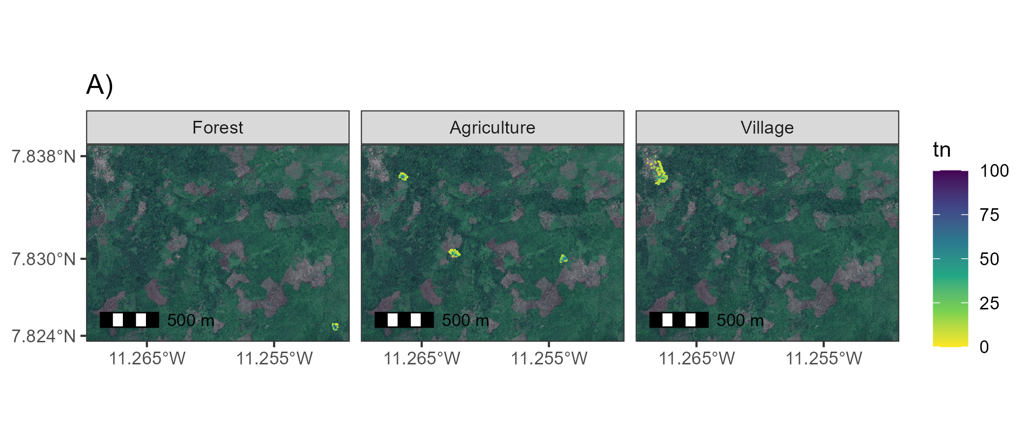

Supplementary Figure 1A. Trap locations and number of trap nights in Baiama. Each cell represents a 49m2 area. The colour of cells relates to the trapping effort within that area in number of trap nights. The facets relate to the land use type of the trapping site. Images obtained from Google maps, copyright 2023 Airbus, CNES/Airbus, Maxar Technologies.

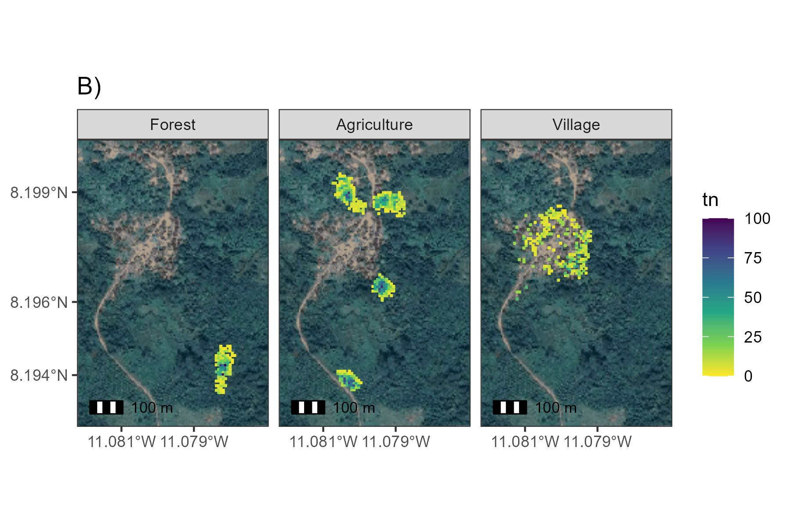

Supplementary Figure 1B. Trap locations and number of trap nights in Lalehun. Each cell represents a 49m2 area. The colour of cells relates to the trapping effort within that area in number of trap nights. The facets relate to the land use type of the trapping site. Images obtained from Google maps, copyright 2023 Airbus, Maxar Technologies.

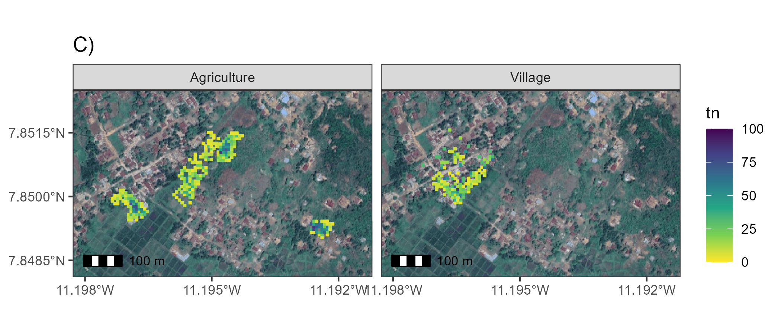

Supplementary Figure 1C. Trap locations and number of trap nights in Lambayama. Each cell represents a 49m2 area. The colour of cells relates to the trapping effort within that area in number of trap nights. The facets relate to the land use type of the trapping site. Images obtained from Google maps, copyright 2023 Airbus, CNES/Airbus, Maxar Technologies.

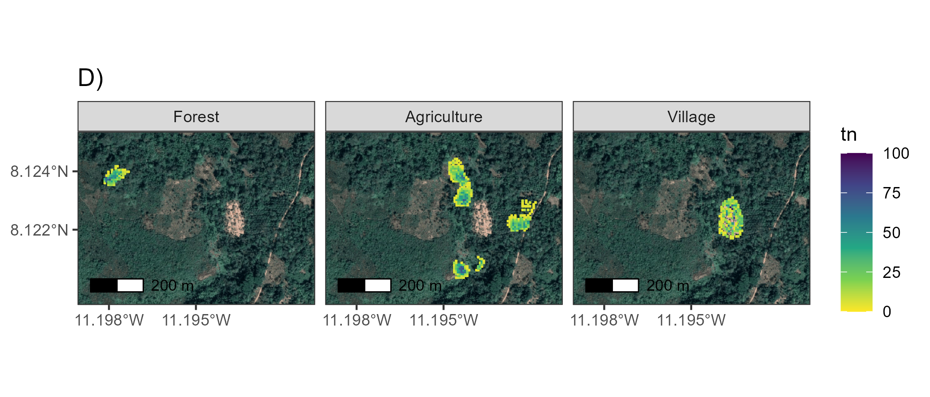

Supplementary Figure 1D. Trap locations and number of trap nights in Seilama. Each cell represents a 49m2 area. The colour of cells relates to the trapping effort within that area in number of trap nights. The facets relate to the land use type of the trapping site. Images obtained from Google maps, copyright 2023 CNES/Airbus, Maxar Technologies.

## Supplementary Figure 2

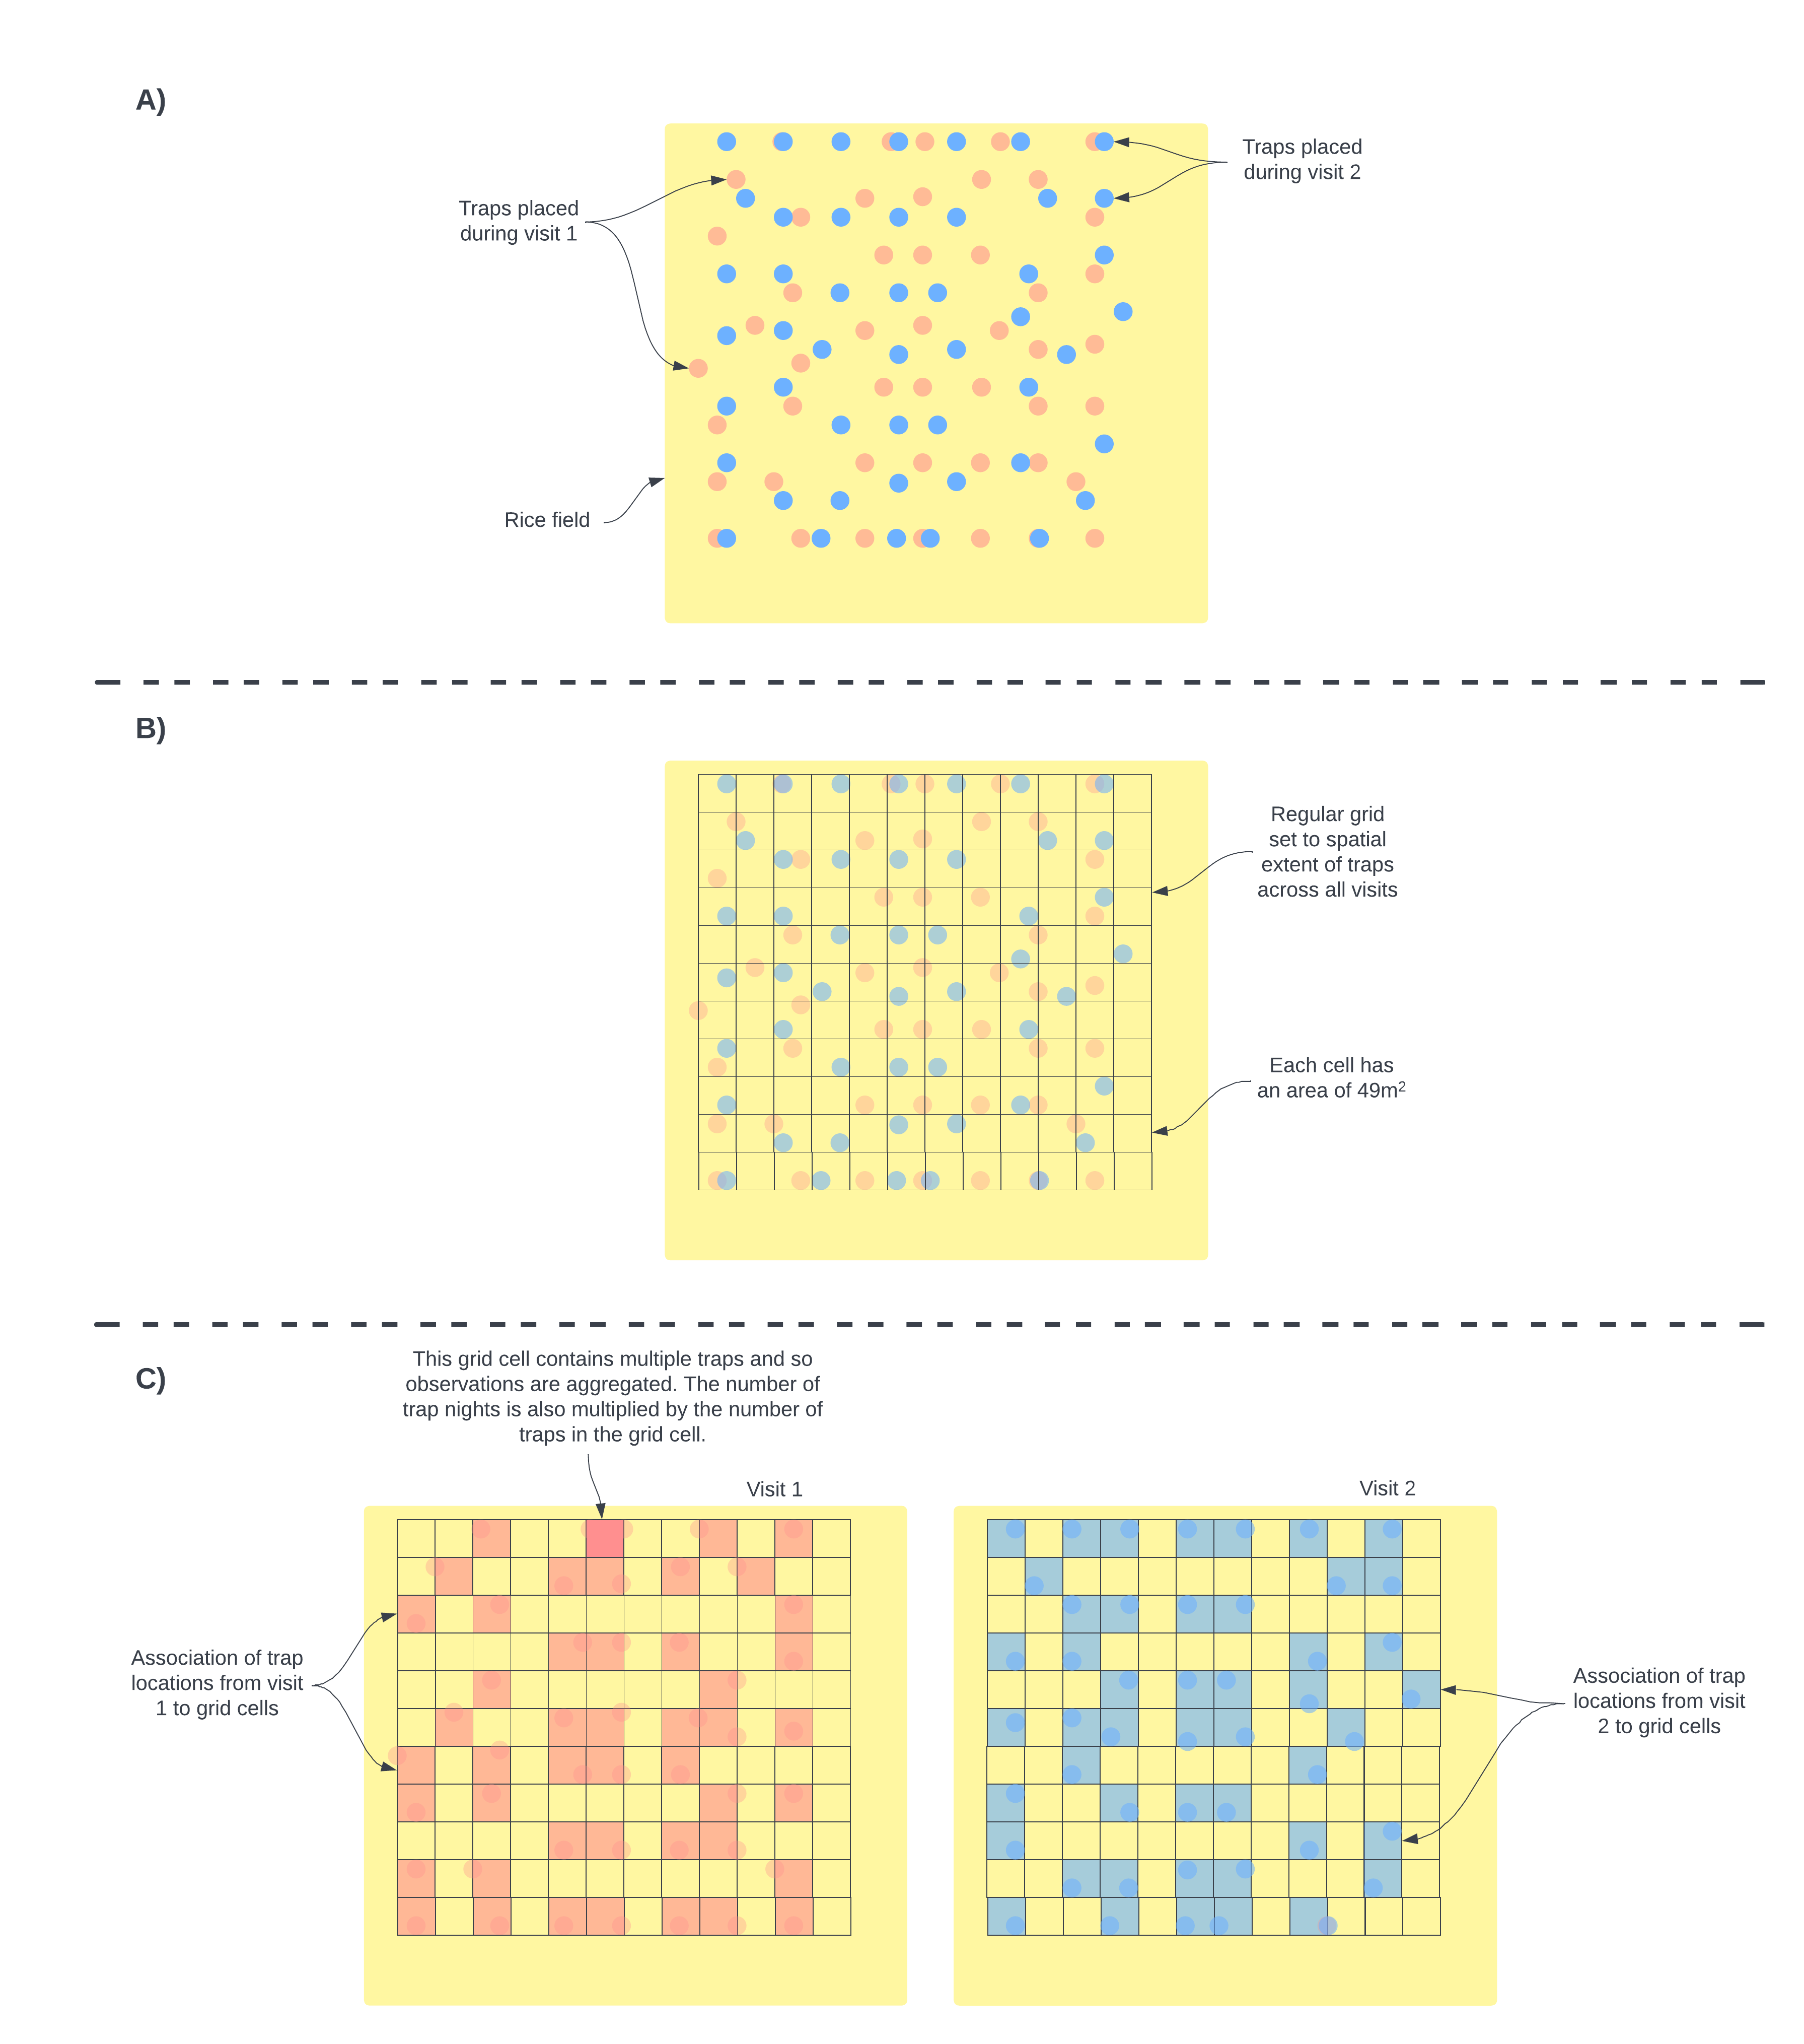

Supplementary Figure 2. Schematic diagram of conversion from trap locations to grids. A) Individual traps were placed in a grid structure in a pre-specified location. While attempts were made to keep trap locations over repeated visits individual traps were often placed in slightly different locations. This is shown in the schematic using different colours to represent different visits. B) To harmonize the locations of traps to coordinates that could be used in the spatial occupancy model we aligned a regular grid with grid cell sizes of 49m2 over the trapping area and assigned individuals traps to these cells. C) The number of traps and therefore the number of trapnights within each grid cell was aggregated for each visit. The number of trap nights informed the detection component of the species occupancy model. Detection histories were produced for each grid cell that was sampled for each species. Grid cells were assigned a 1 if any trap within the grid cell detected the species and 0 otherwise.

## Supplementary Figure 3

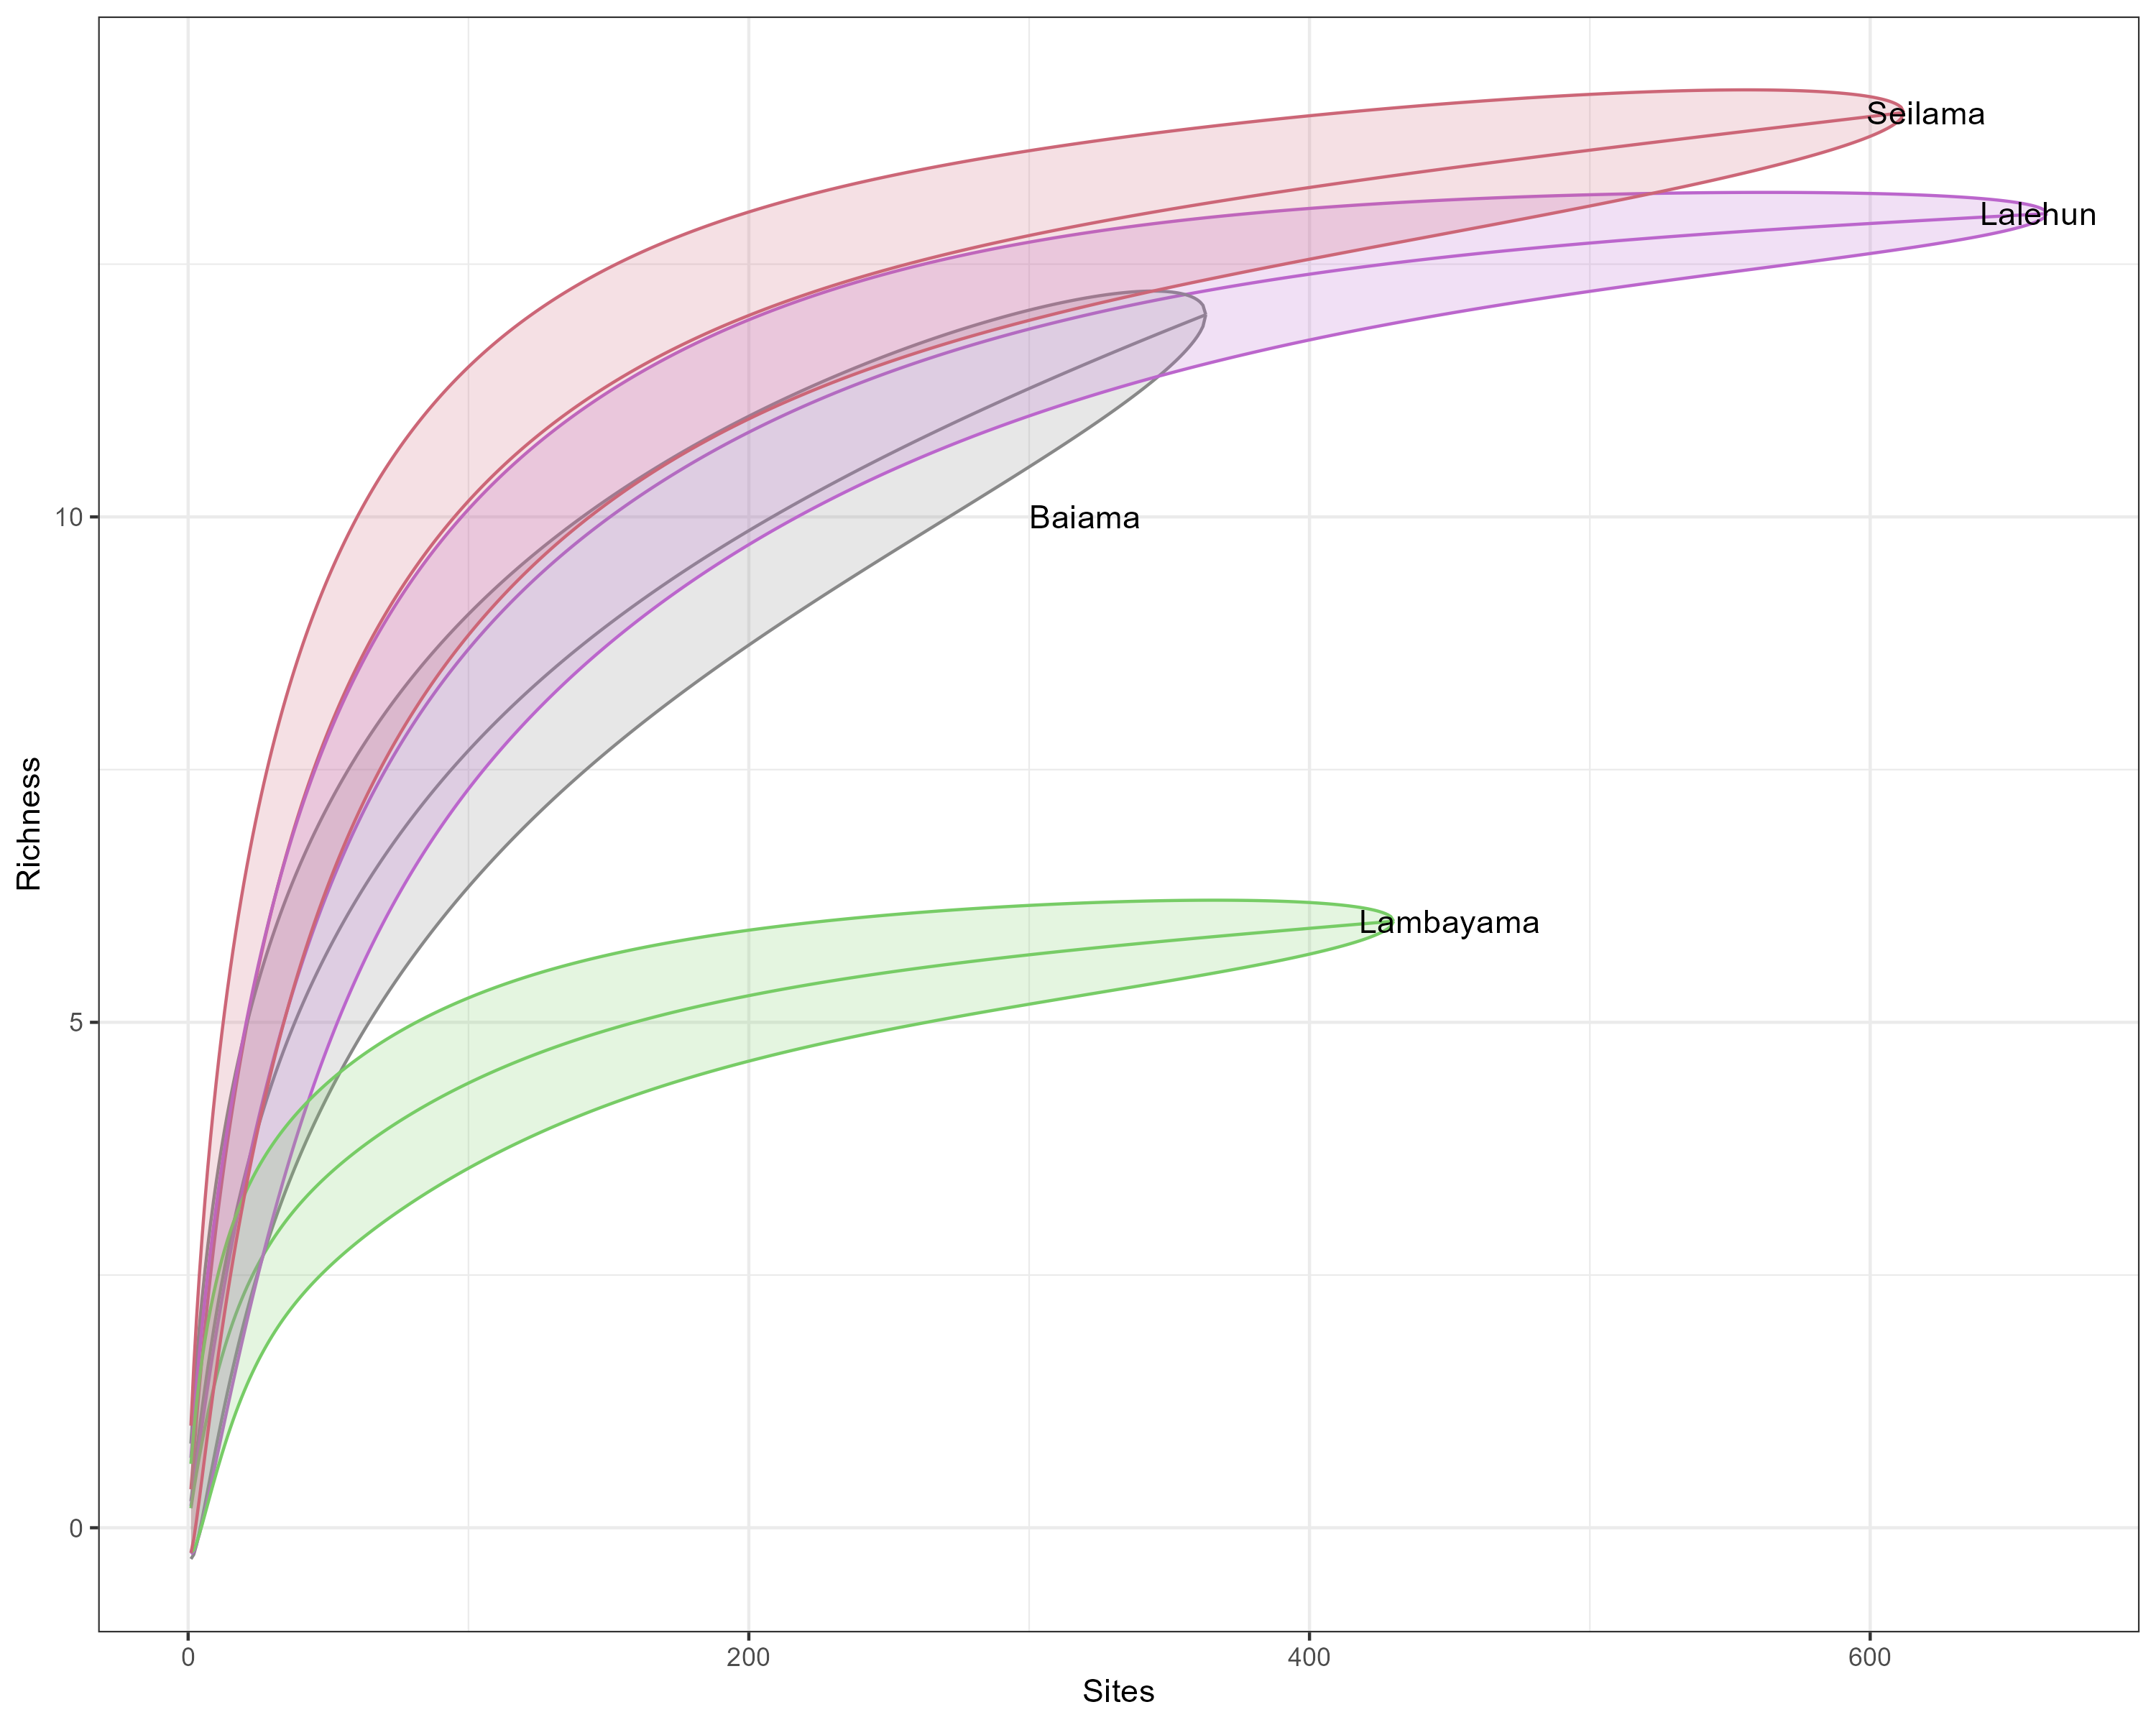

Supplementary Figure 3A. Species accumulation curves by village site.

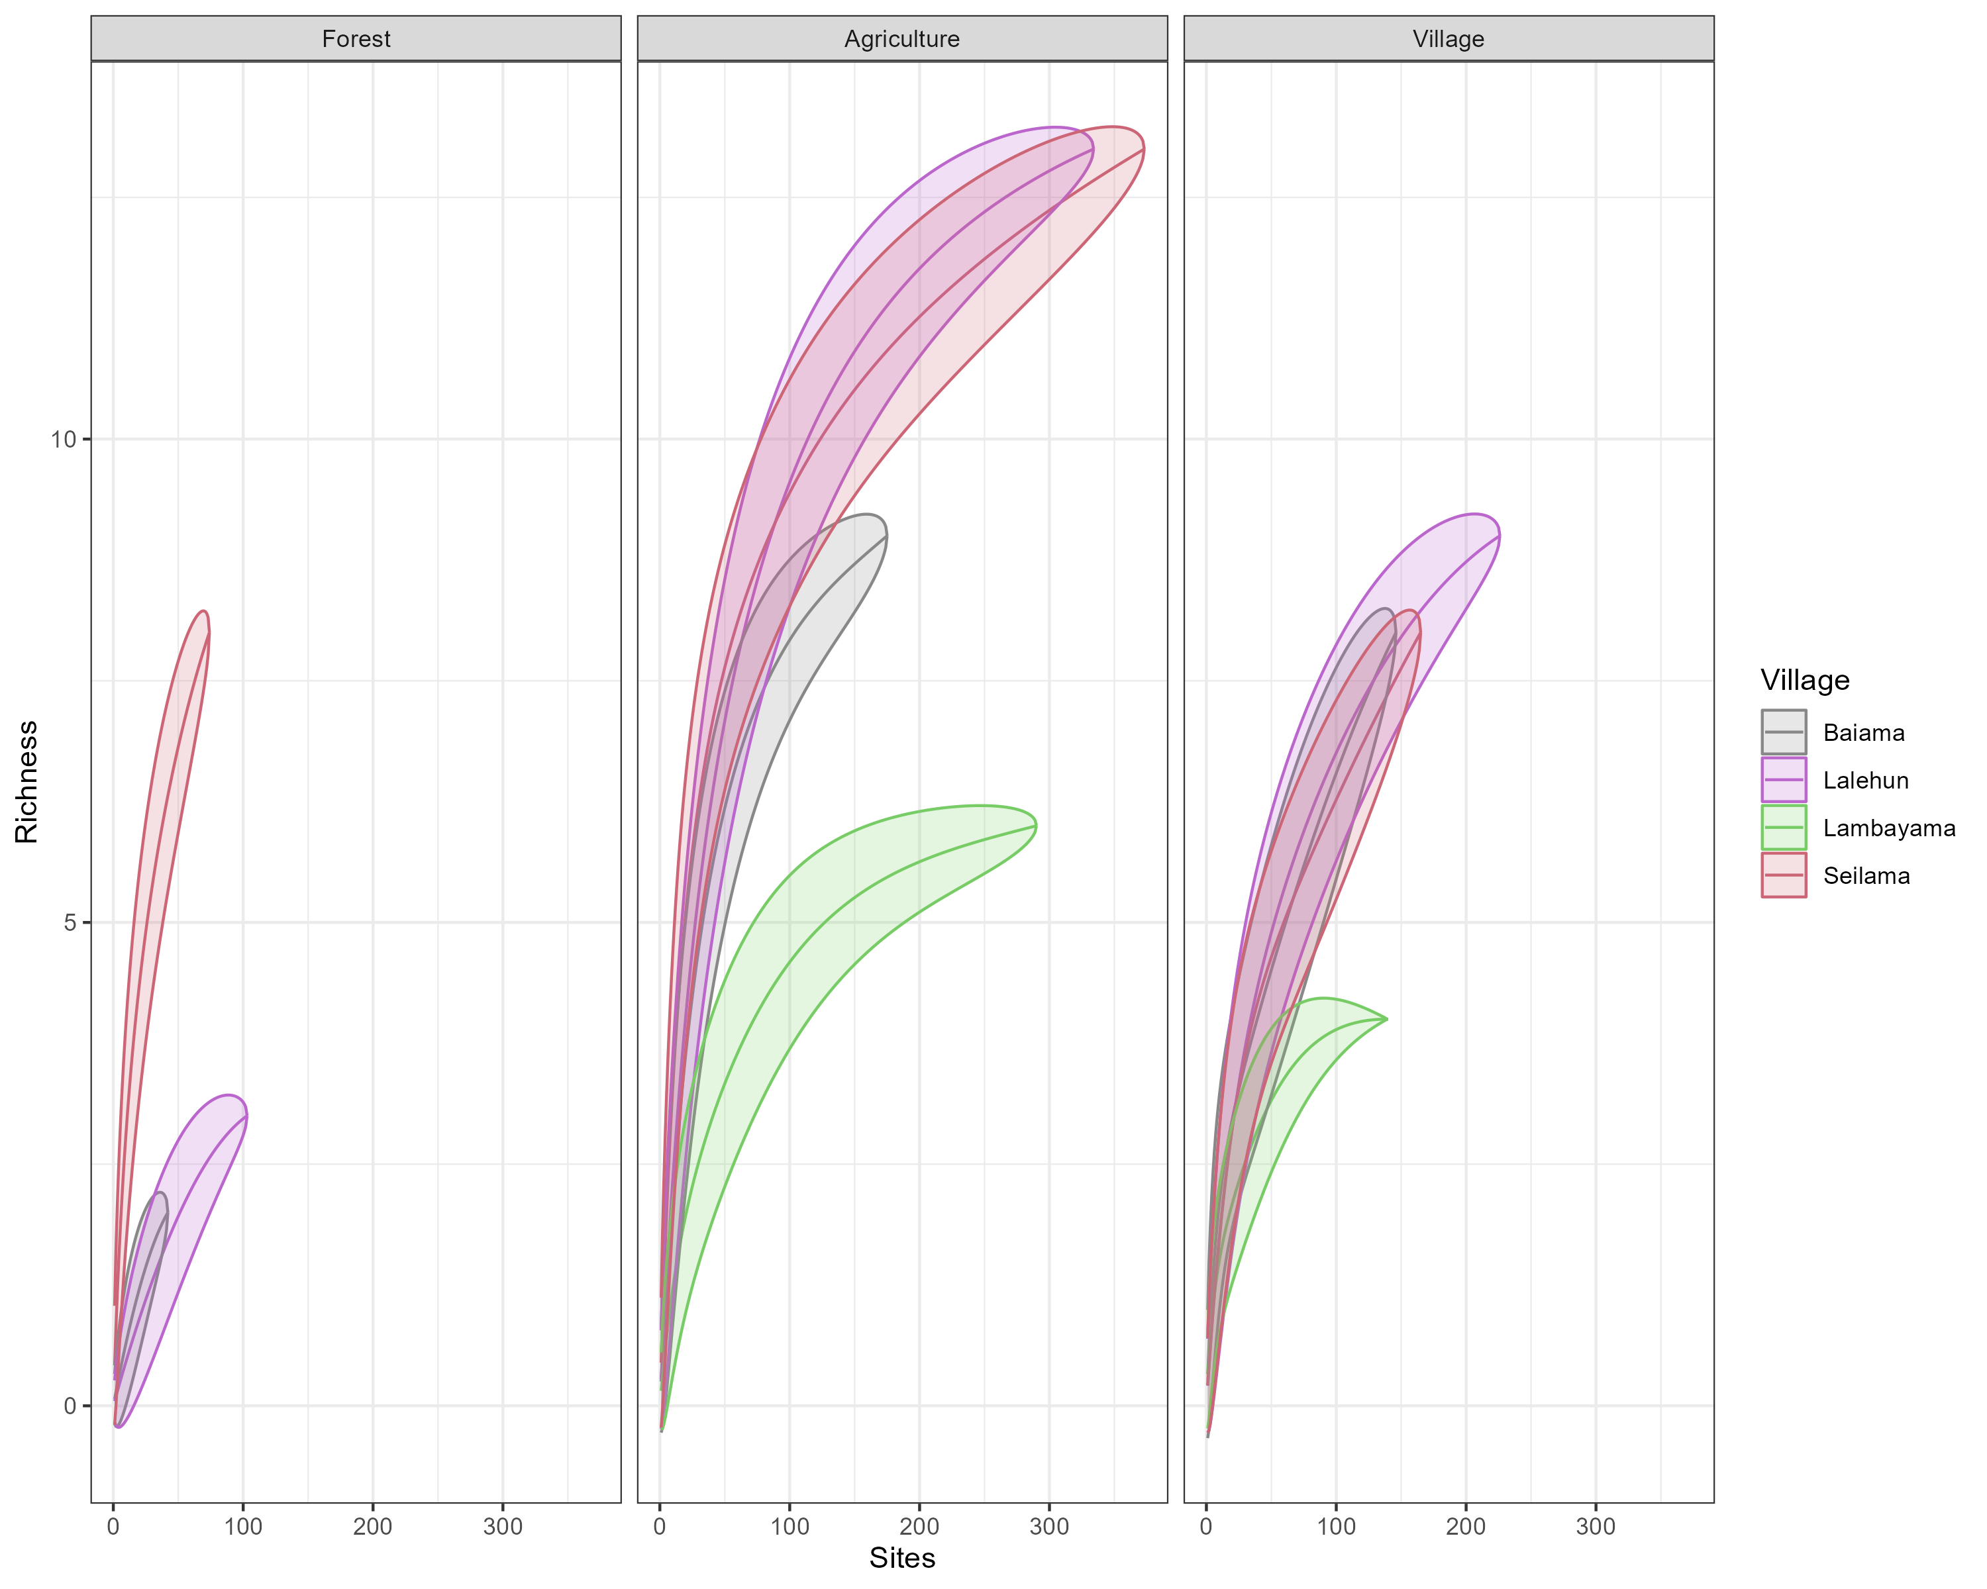

Supplementary Figure 3B. Species accumulation curves by village site stratified by landuse type.

## Supplementary Figure 4

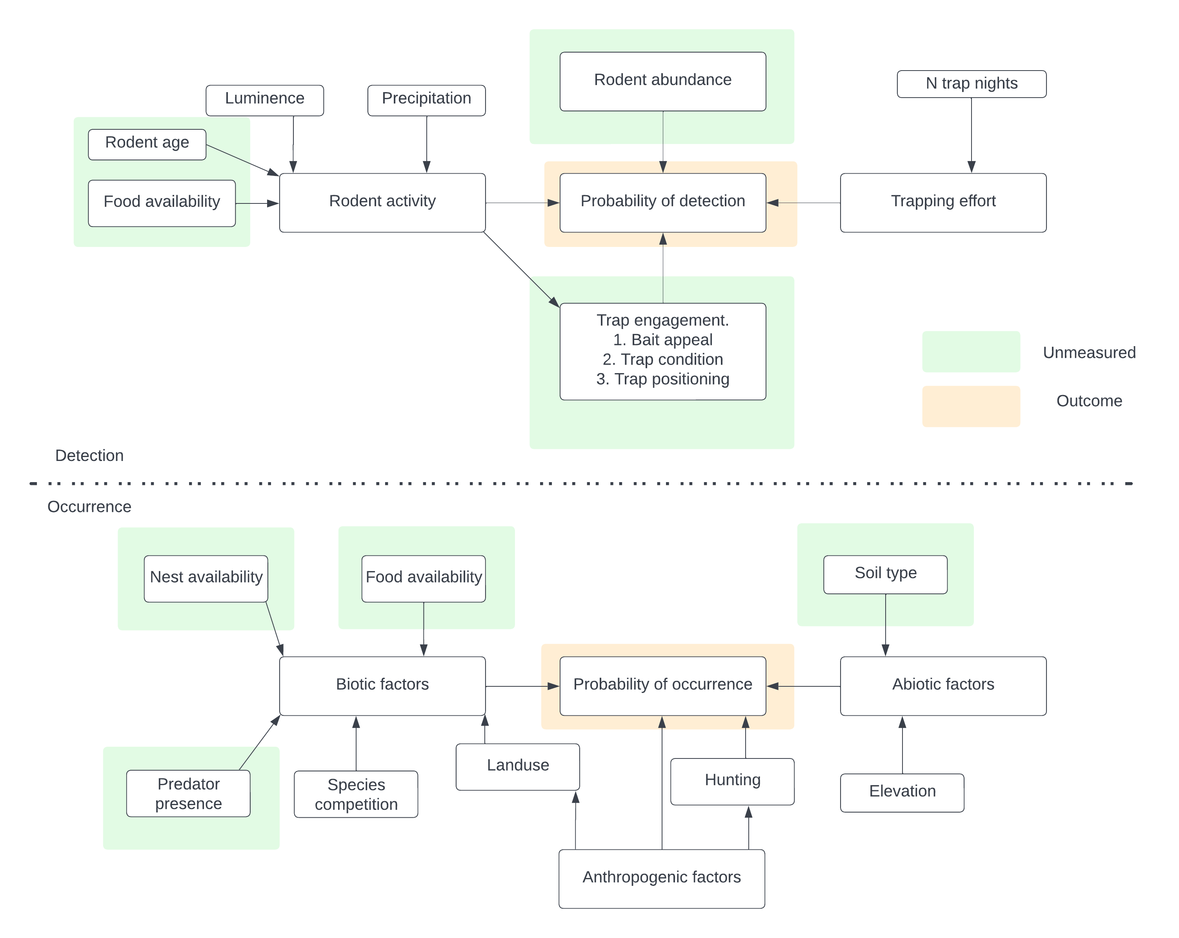

Supplementary Figure 4. Conceptual model used to identify potential causal pathways for inclusion of variables for the occupancy and detection model specification.

## Supplementary Figure 5

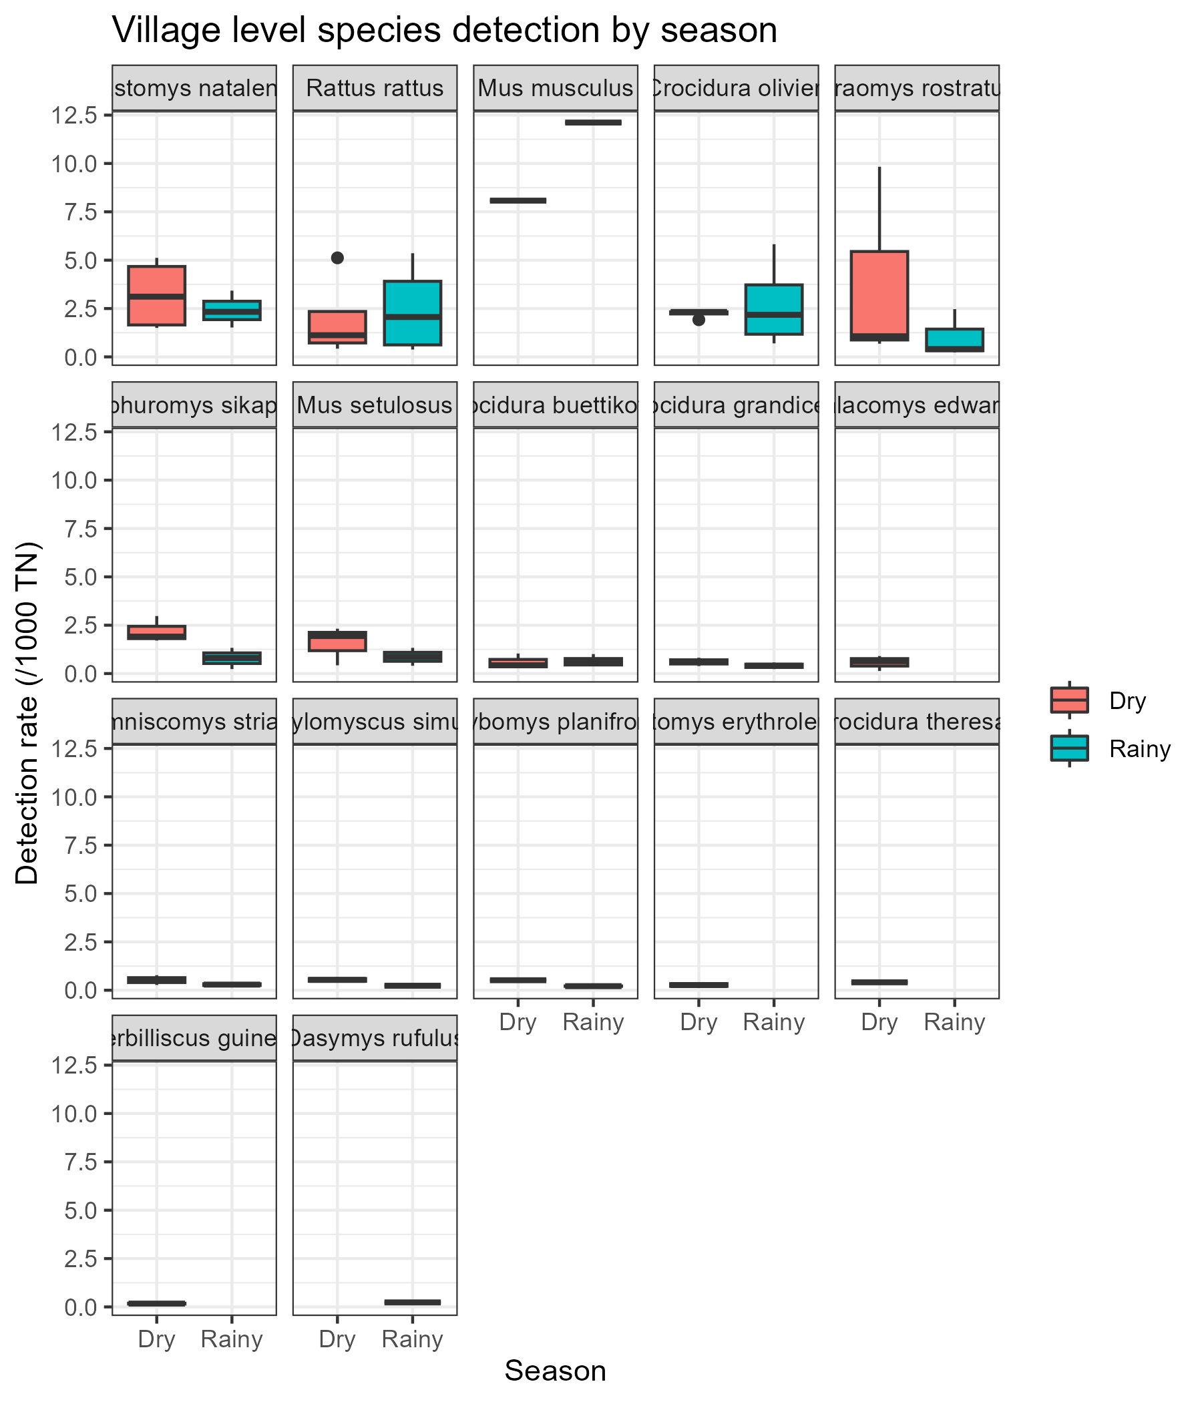

Supplementary Figure 5A. The detection rate for all species by season (Rainy = May-October, Dry = November-April) of trapping activity.

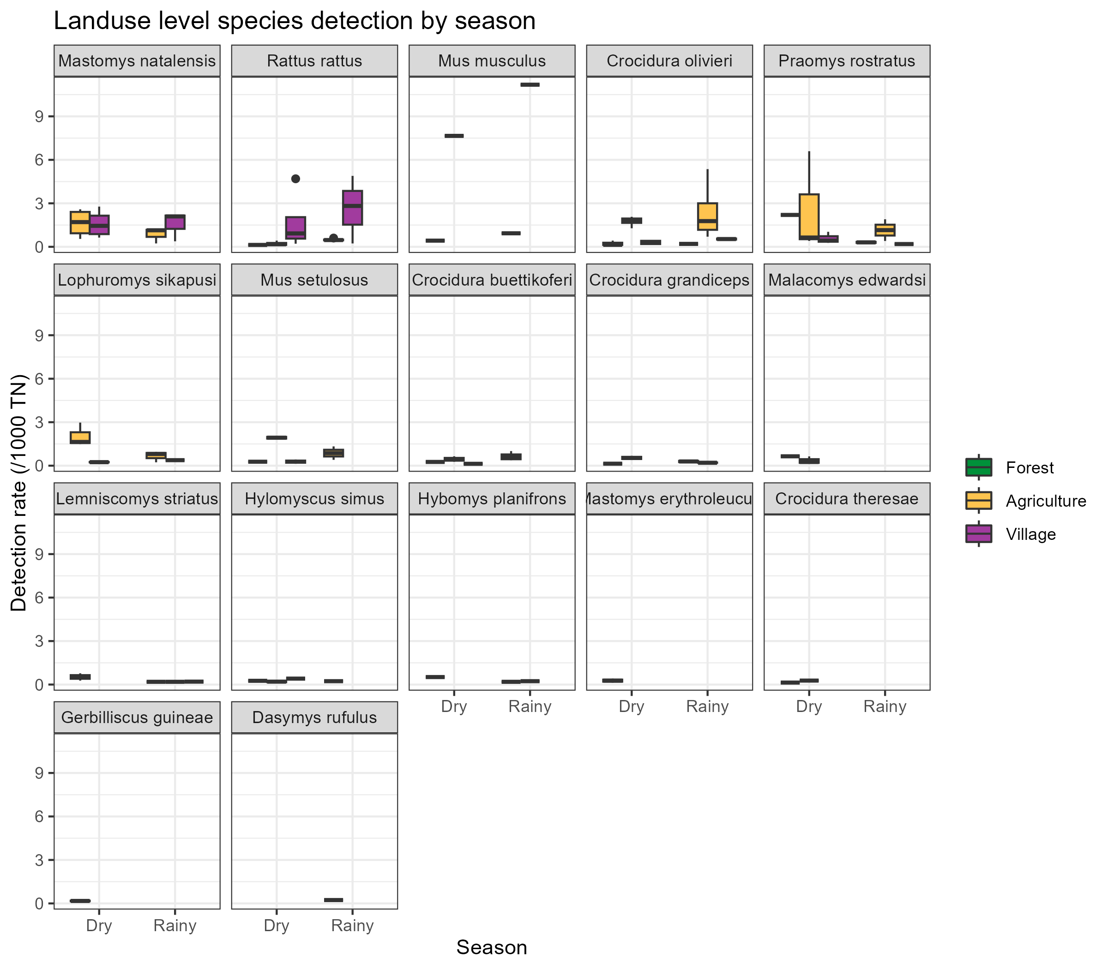

Supplementary material 5B. The detection rate for all species by season (Rainy = May-October, Dry = November-April) stratified by land use type.

## Supplementary Figure 6

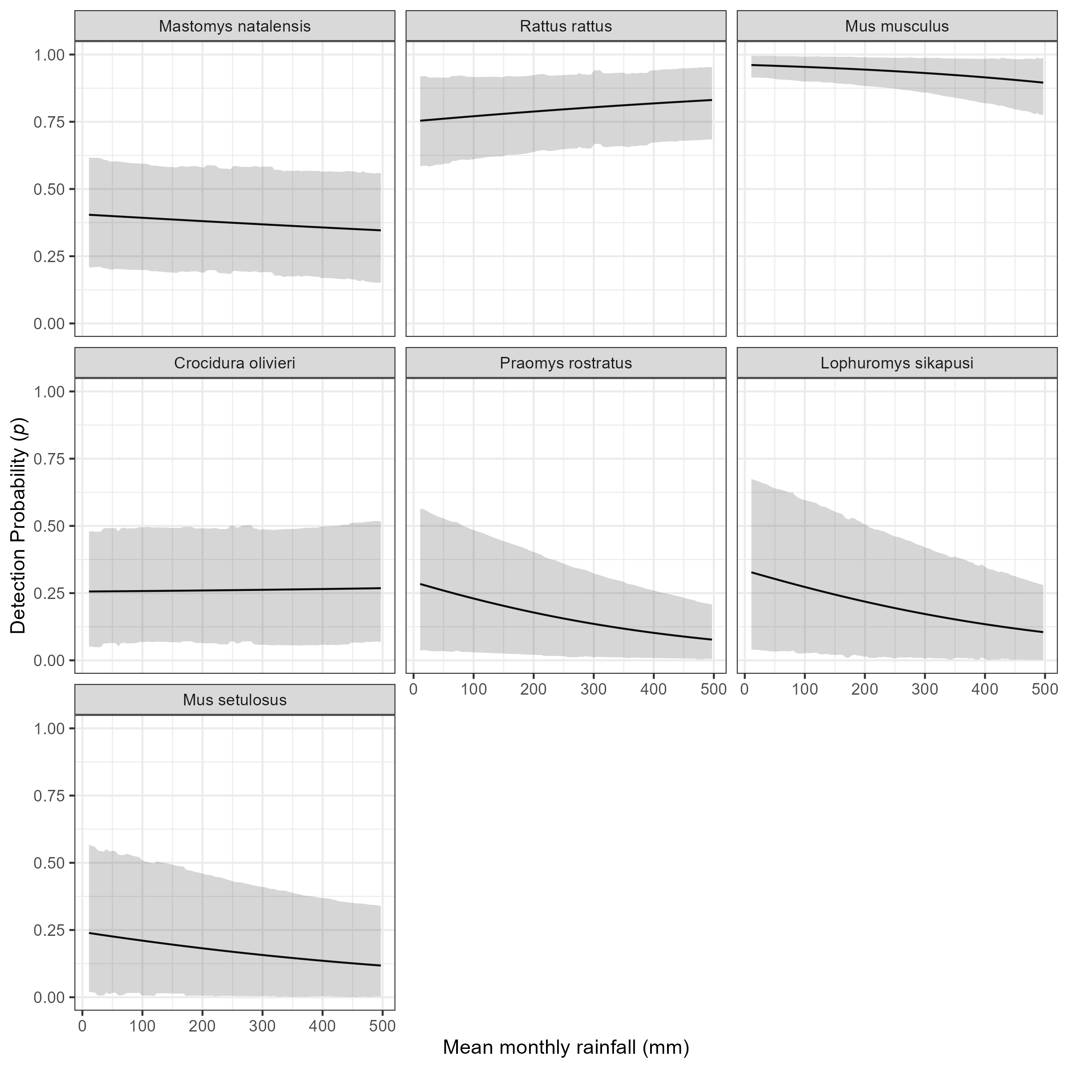

Supplementary Figure 6A: The marginal effect of mean monthly rainfall on the probability of detection of a species in a grid cell. The black line shows the mean modelled probability of detection for the amount of monthly rainfall, the shaded grey region represents the 95% Credible Interval (CrI). Probability of detection varies by species with higher values for the invasive rodent species M. musculus and R. rattus, than the native rodent species. There is a general response of decreasing probability of detection with increasing rainfall.

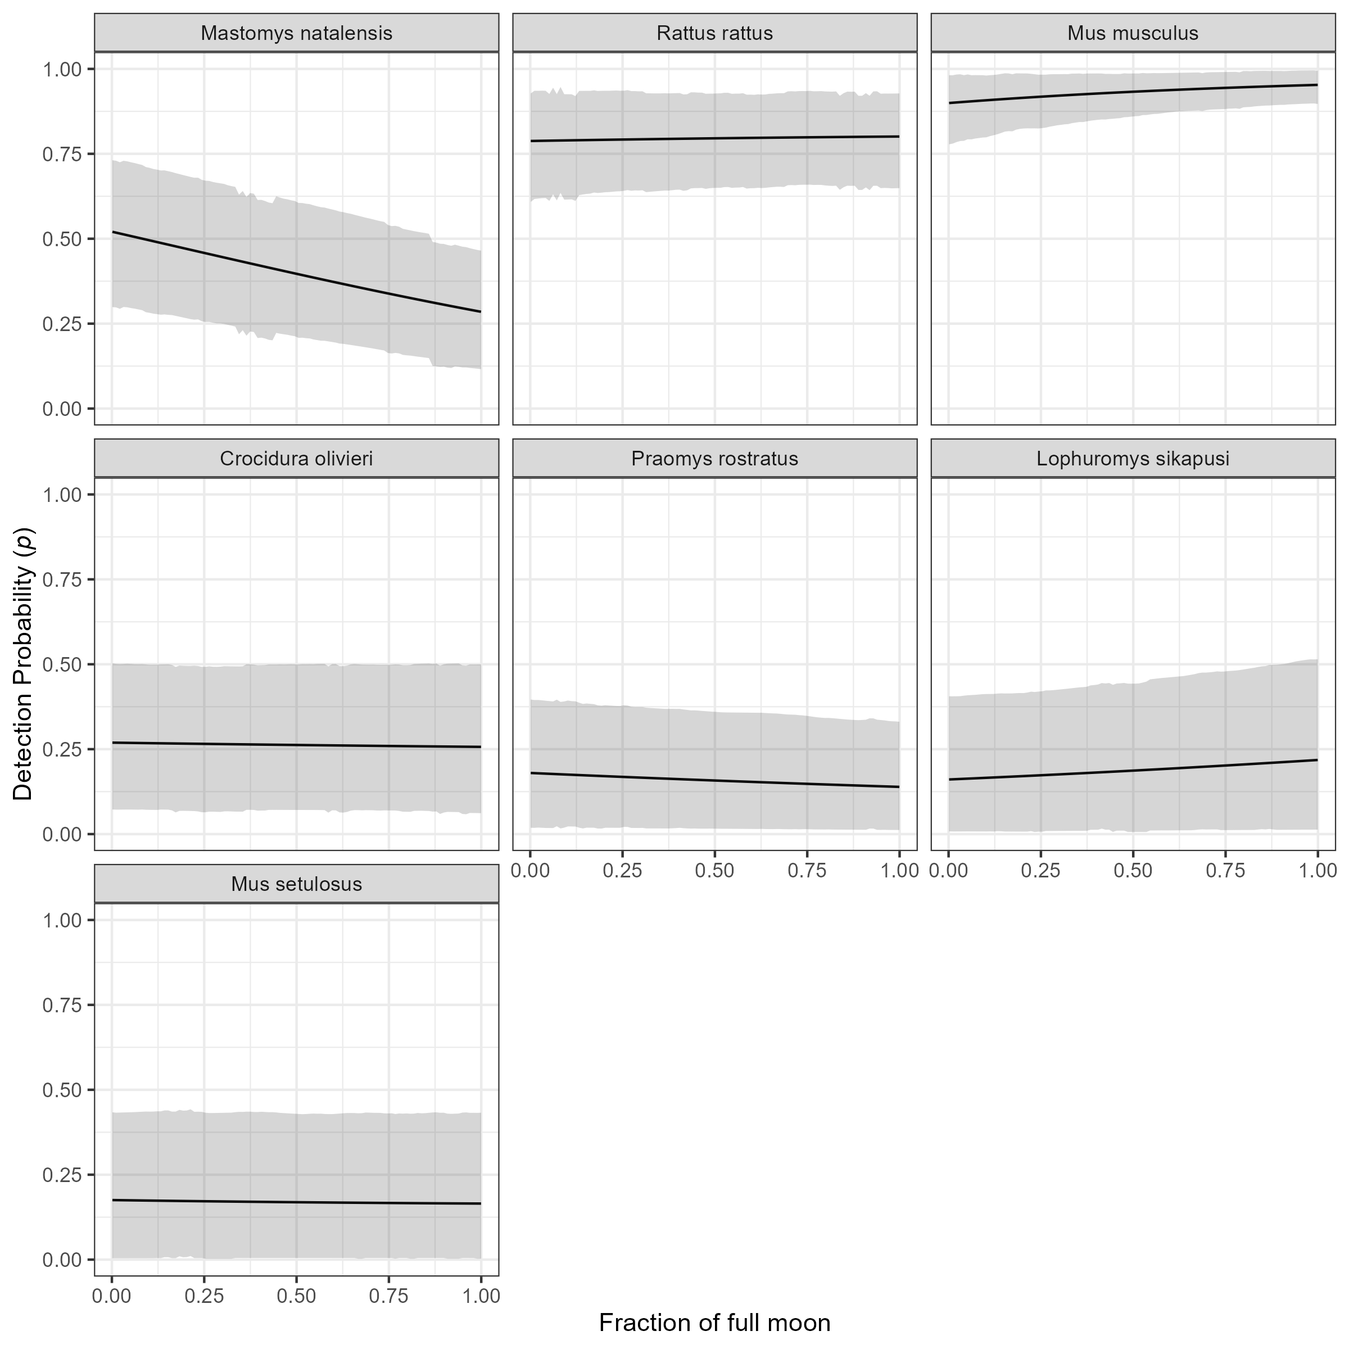

Supplementary Figure 6B: The marginal effect of the fraction of the full moon on the probability of detection of a species in a grid cell. The black line shows the mean modelled probability of detection for the moon phase, the shaded grey region represents the 95% CrI. Probability of detection varies by species with higher values for the invasive rodent species M. musculus and R. rattus, than the native rodent species. There is no important response to moon phase for most species. The probability of detection appears to fall for M. natalensis with increasing moon phase but the credible intervals overlap for the entire range.

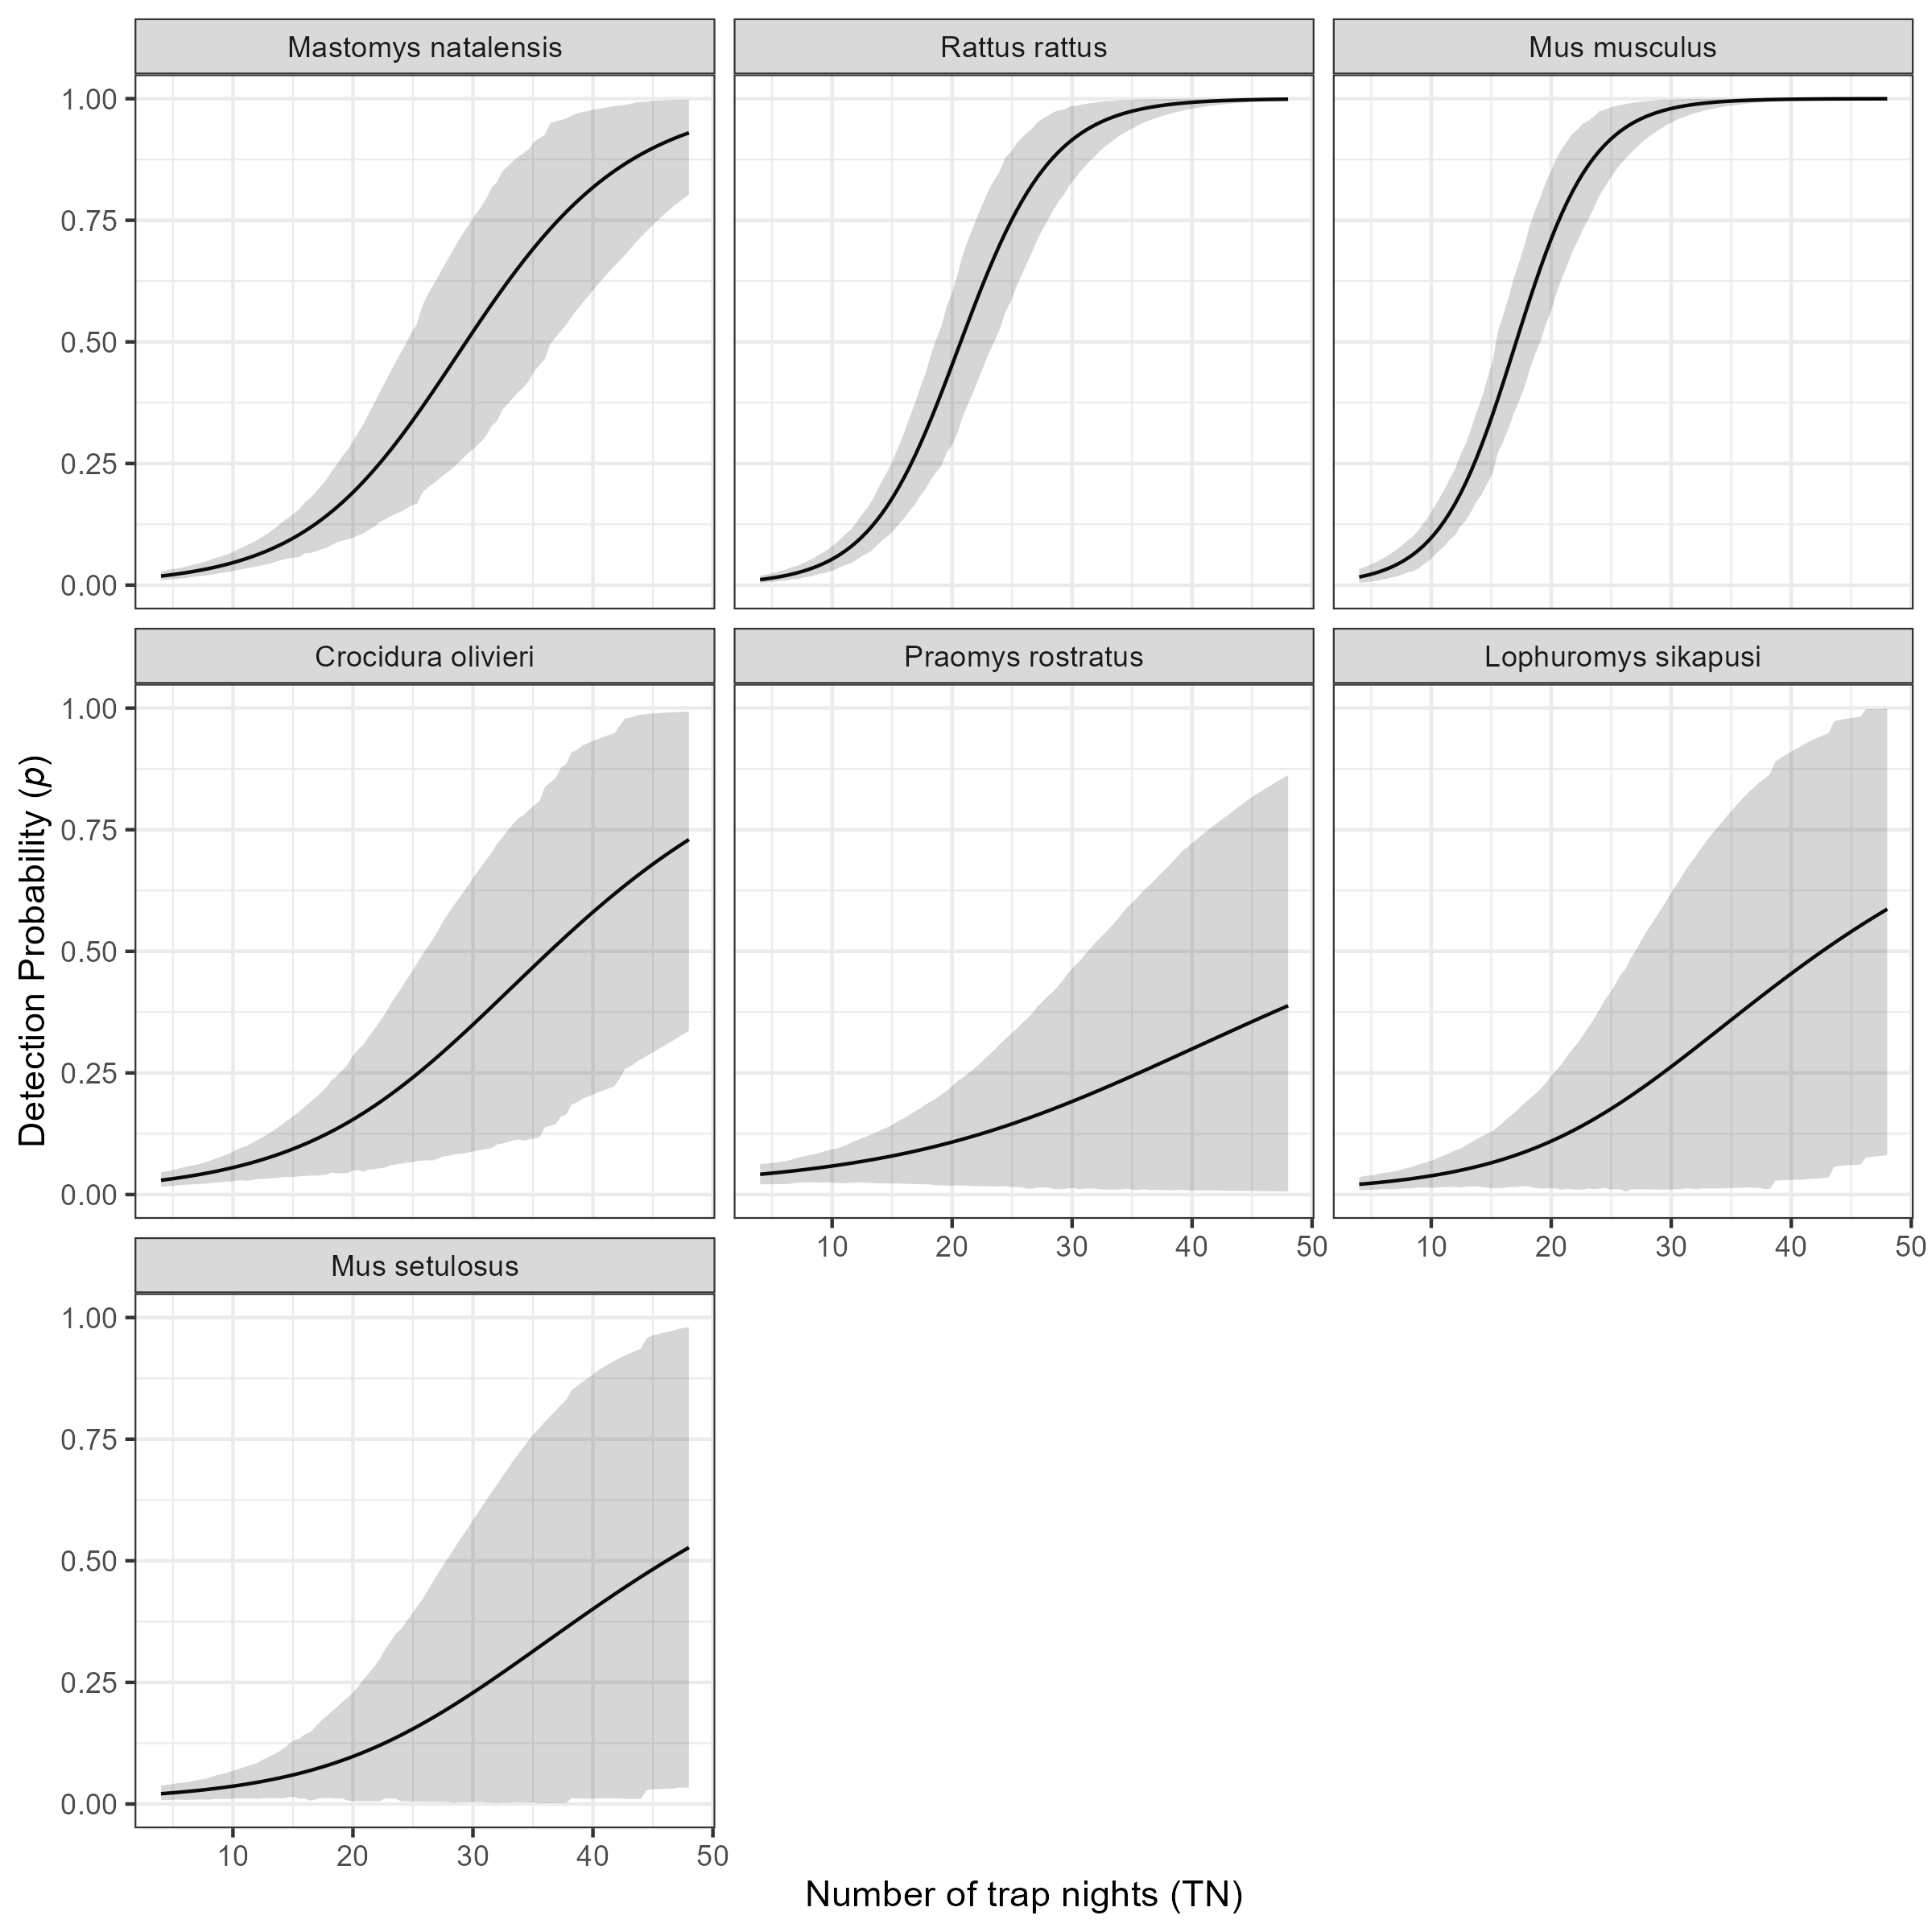

Supplementary Figure 6C: The marginal effect of trapping effort (TN) on the probability of detection of a species in a grid cell. The black line shows the mean modelled probability of detection trapping effort, the shaded grey region represents the 95% CrI. Probability of detection is low for all species at low levels of TN. The probability of detection with increasing TN varies by species. The invasive rodent species M. musculus and R. rattus show a sinusoidal response over the range of TNs that were observed in this study with the probability of detection being greater than 50% at relatively low numbers of TN (17 and 22 respectively). Much greater trapping effort were required to obtain the same probability of detection for the native rodent species. Only M. natalensis requiring 29 TN to reach a probability of 50% detection.